REQUEST FORM

- when clients forget a required field the page doesn’t have to refresh and jump on top but it must stay where there is the request form otherwise clients don’t understand that there was an error.
Moreover please delete the sentence “Oops ! Something went wrong. Please check it again”.

NEW VERSION WRONG
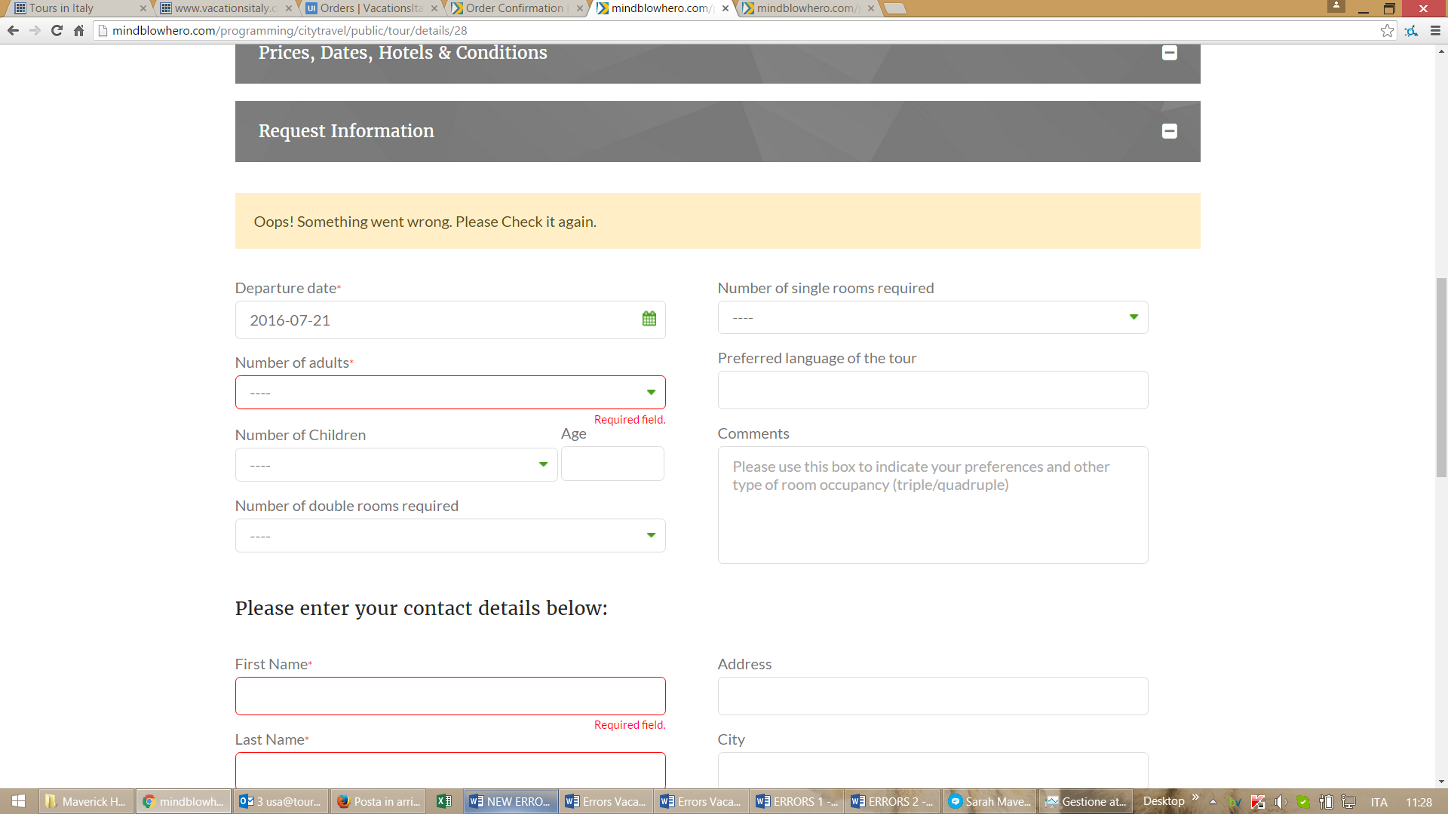

OLD VERSION CORRECT
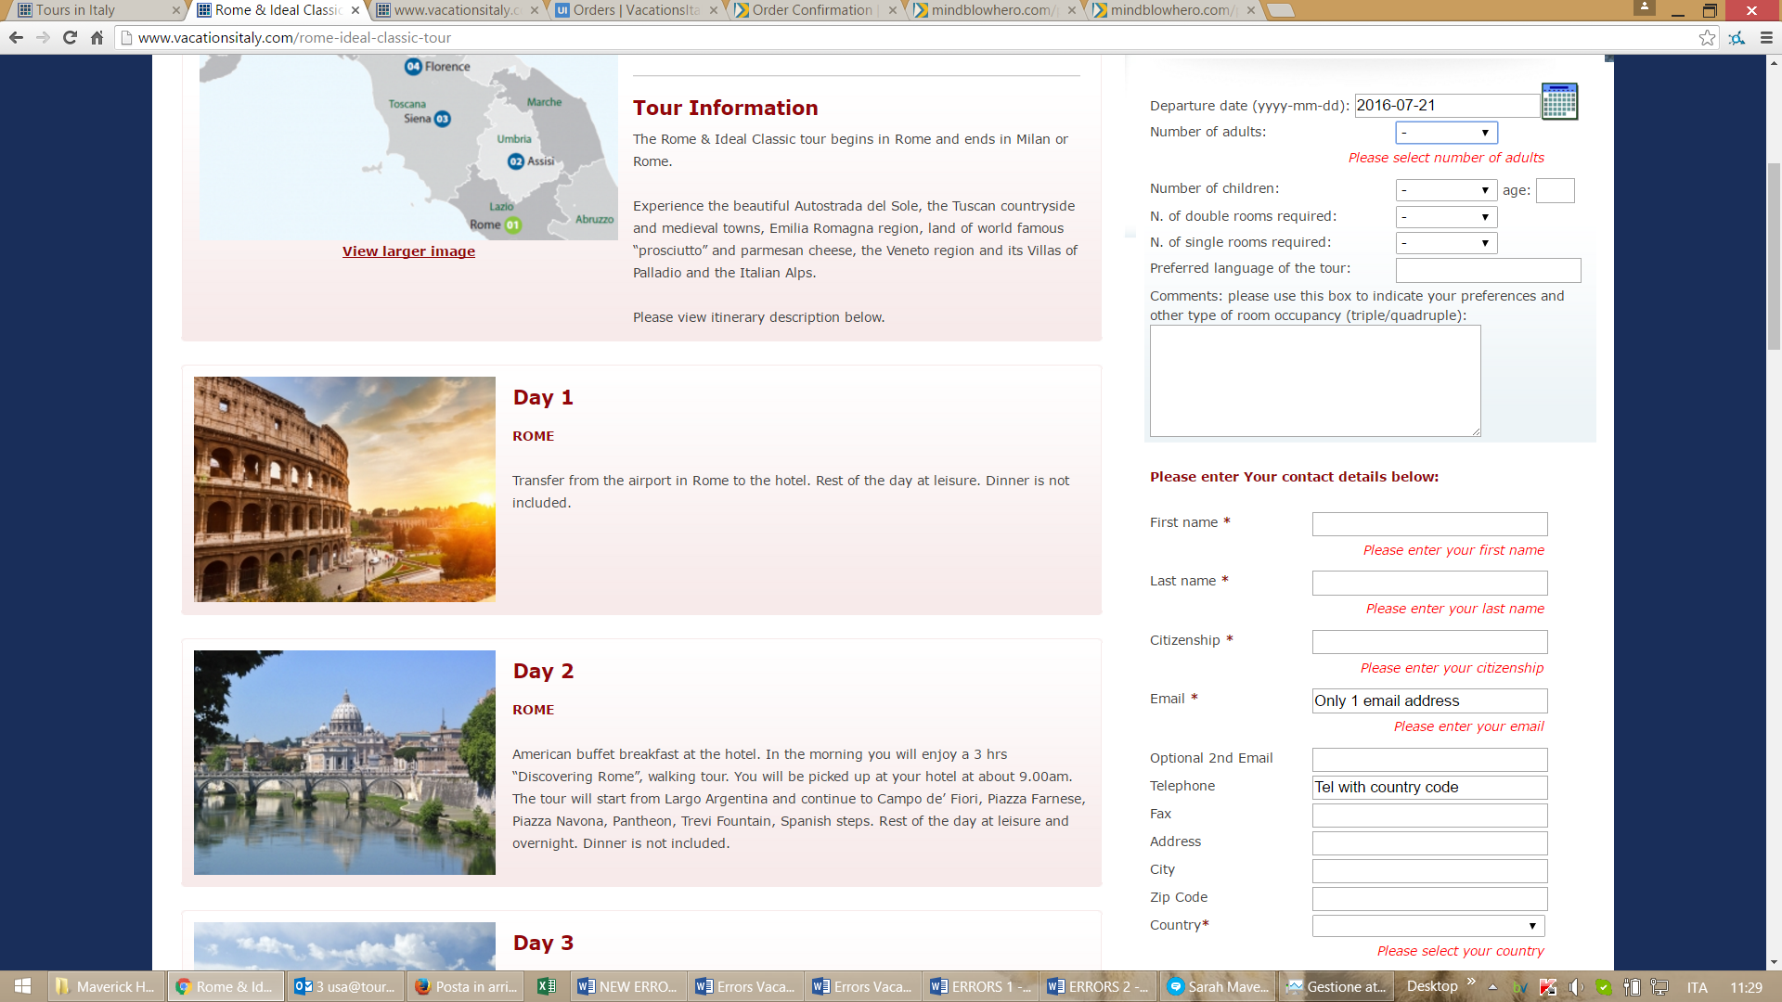

- when clients enter a wrong security code the page doesn’t have to refresh and jump on top but it must stay where there is the request form otherwise clients don’t understand that there was an error.
Moreover please delete the sentence “Oops ! Something went wrong. Please check it again”.
- The sentence in red ”You request was not submitted because you entered a wrong security code. Please write again the correct security code and press the button submit“ must be written in a larger font the same of the rest of the request form. There is an error because it must be Your and not You. This sentence must be editable in CMS.

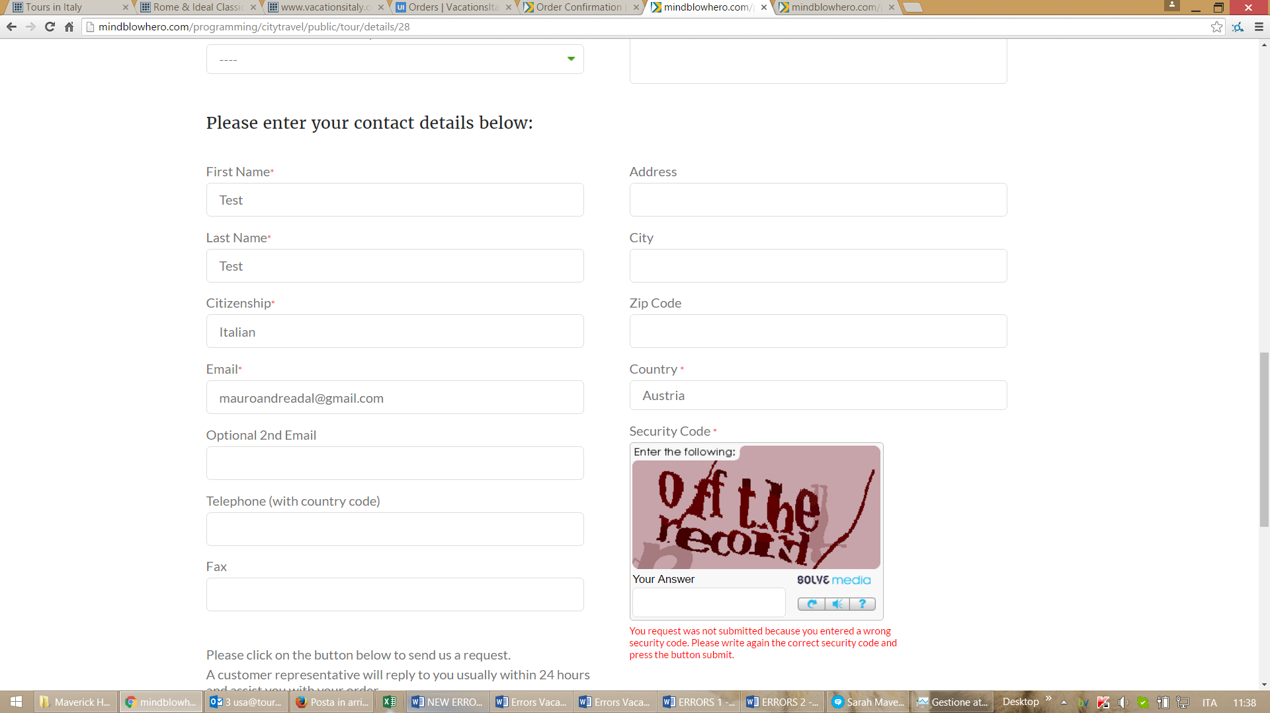

- please check screenshot below because with Firefox the design of request form is not nice and there are some strange green arrows next to drop down menu

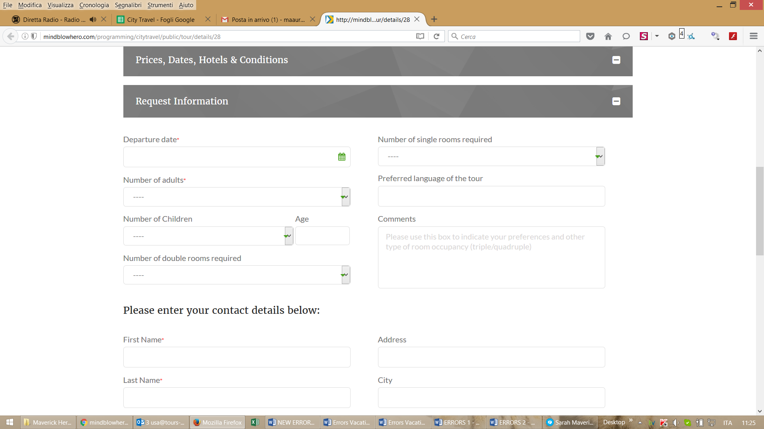

- The list of countries in Drop down menu is not in alphabetical order

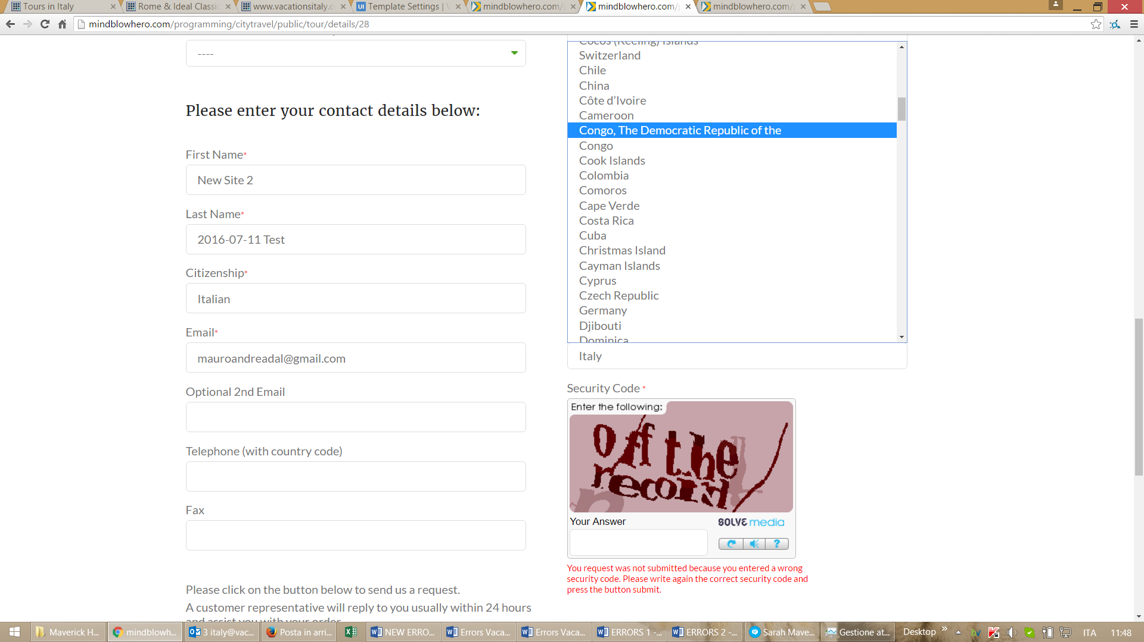

TOUR PAGE
- Accordions of “Prices, Dates, Hotels & Conditions” and “Request Form” must be automatically open in Desktop Version. This was already done so I can’t understand why you changed again. Please tell to programmer to check all what was agreed in the Google spreadsheet
https://docs.google.com/spreadsheets/d/1GcjrXkl8ecmm2BiI9cPAPmnYy6GbBYy-cBejxmNTbOw/edit?pref=2&pli=1#gid=0
Accordion shown in desktop version
http://maverickpreviews.com/design/citytravel/touring-info-3-accordion-shown.html
Accordion hidden for mobile version
http://maverickpreviews.com/design/citytravel/touring-info-3-accordion-hidden.html

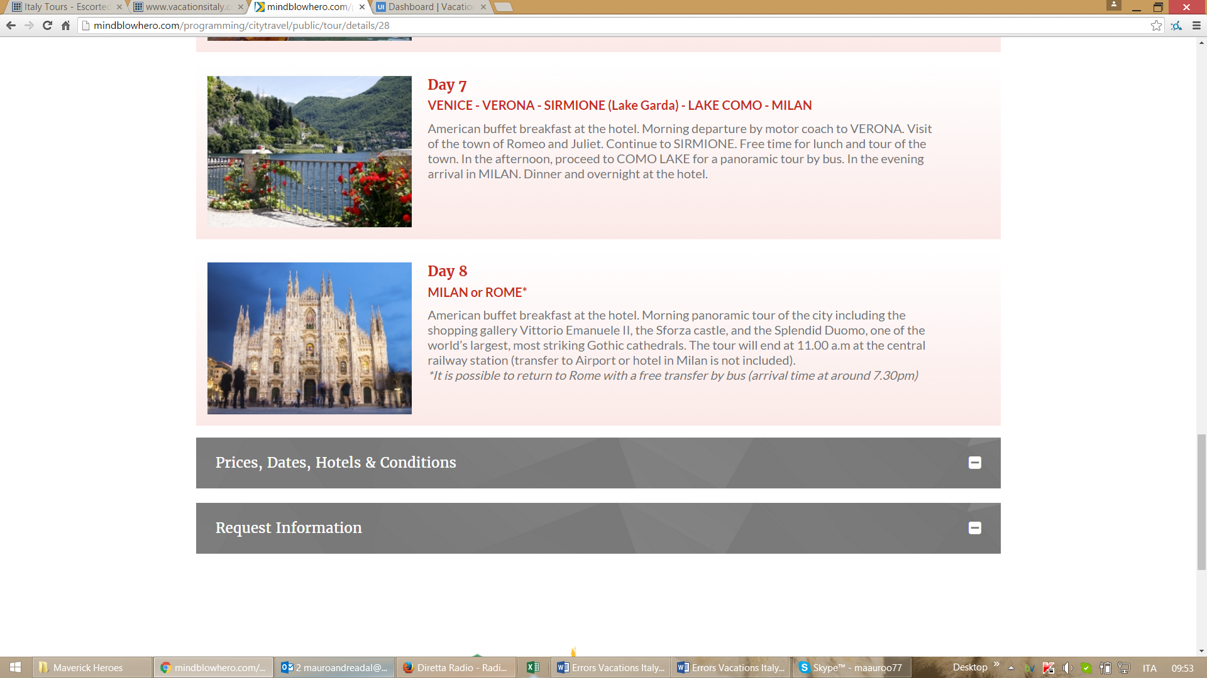

- CURRENCY SYMBOLS and TABLES of Dates, Prices and Hotels
You changed the symbols of currencies and the format of the table with dates and prices. Please change the symbol of currencies and make the first row of the table bigger and the rows inside of the table smaller

WHAT YOU DID THAT IS WRONG
http://mindblowhero.com/programming/citytravel/public/tour/details/3
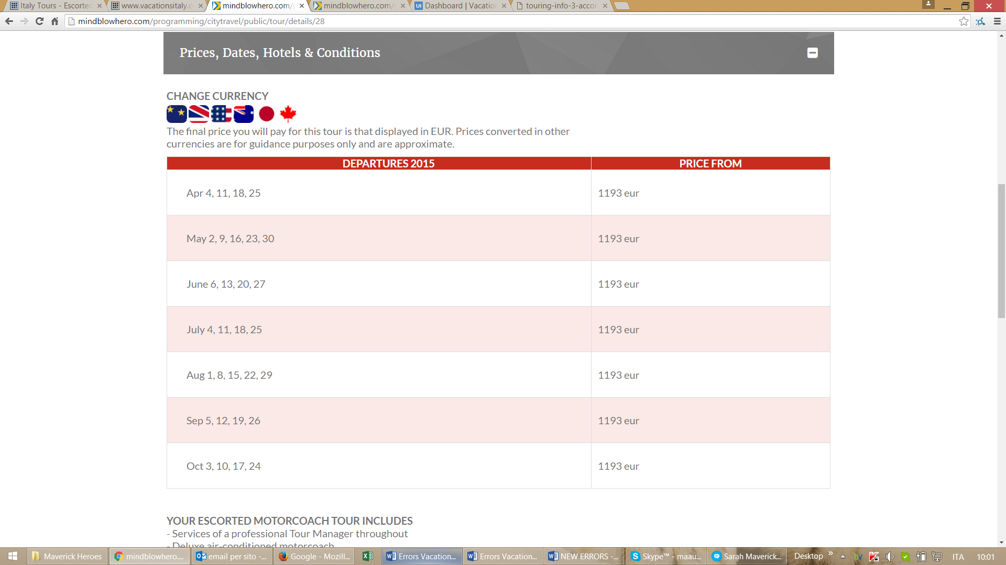

WHAT WE AGREED THAT IS CORRECT
http://maverickpreviews.com/design/citytravel/touring-info-3-accordion-shown.html
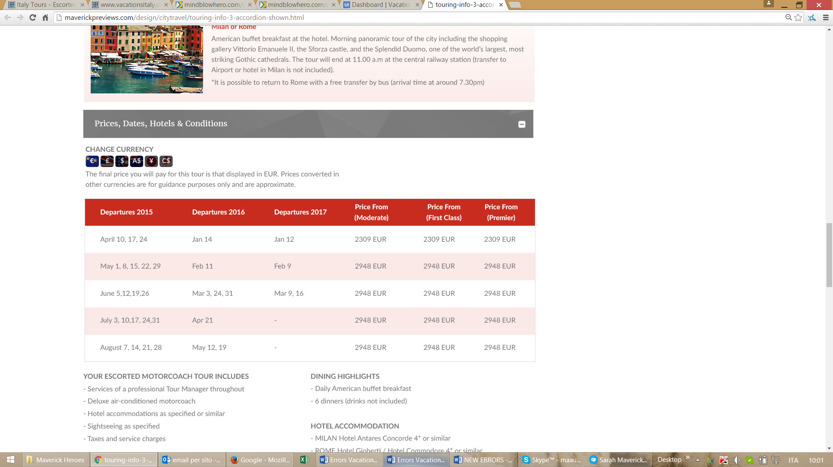

EMAIL
- At the end of the email we and clients receive after a request there must be a sentence “To send us a message, to make corrections or changes to your order please click on the link below. You will be directed to your order page:”. This thing was already done so I don’t understand why it appeared again.
This sentence must be editable in CMS
- The emails addresses in the field To: must be both emails of the client. This should be valid for the email sent to client and the email sent to us. Now there is an error because you write only one email address in the email received by client and you write our email address in the email received by us.

NEW VERSION WRONG
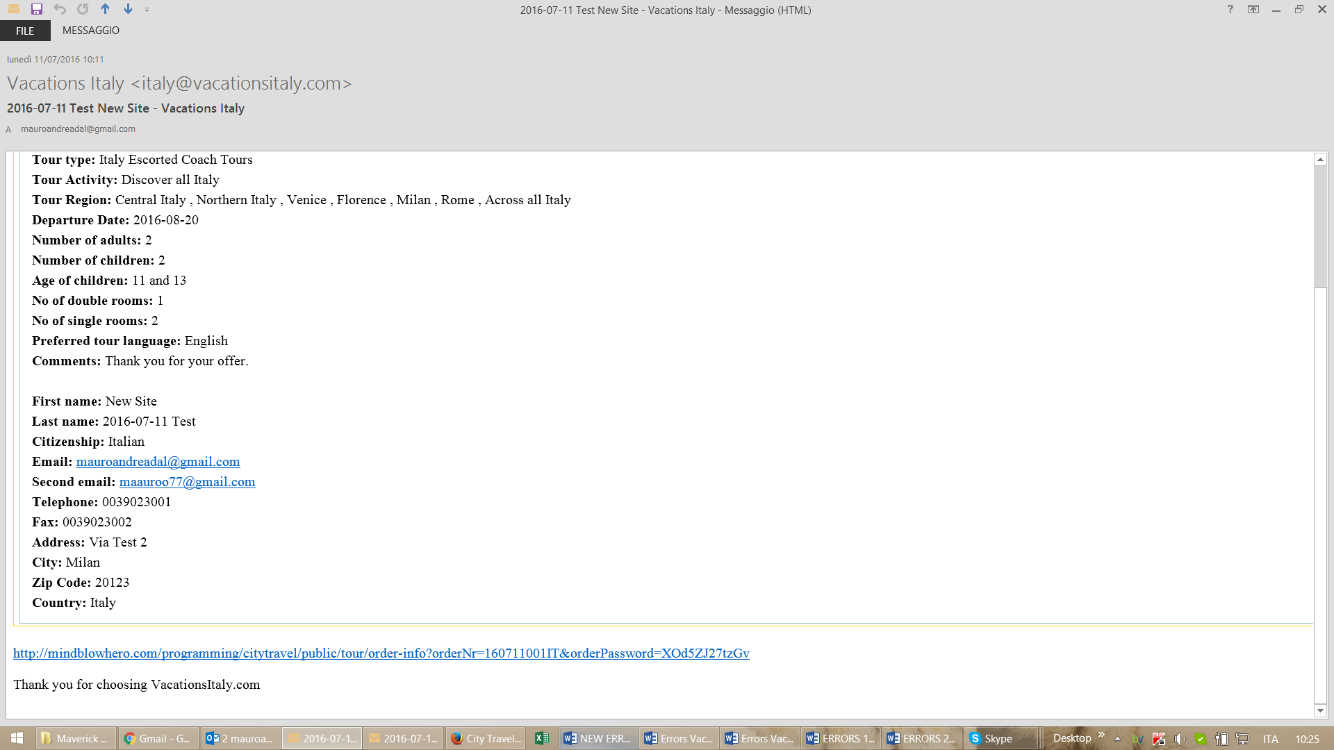

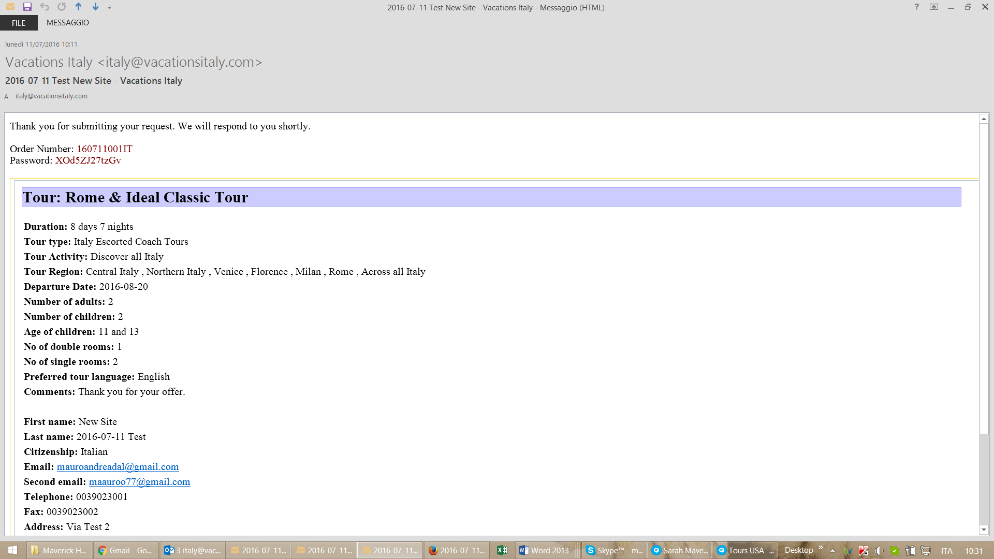

OLD VERSION CORRECT
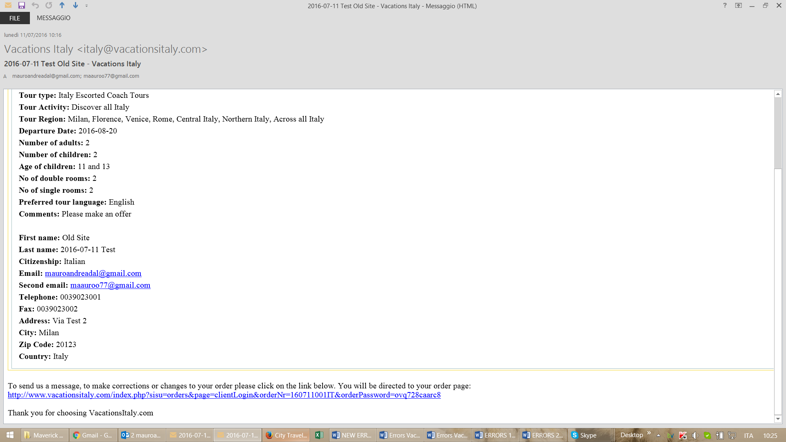

- when a client sends a message from his order information page the email is wrong because:
1) order number and password should be in red
2) there should be a space before the sentence “To send us a message, to make corrections or changes to your order please click on the link below. You will be directed to your order page: ....”
3) it does not attached a file if client sends a file.
4) the system does not keep the format of the message but put all the text next to each other

NEW VERSION WRONG
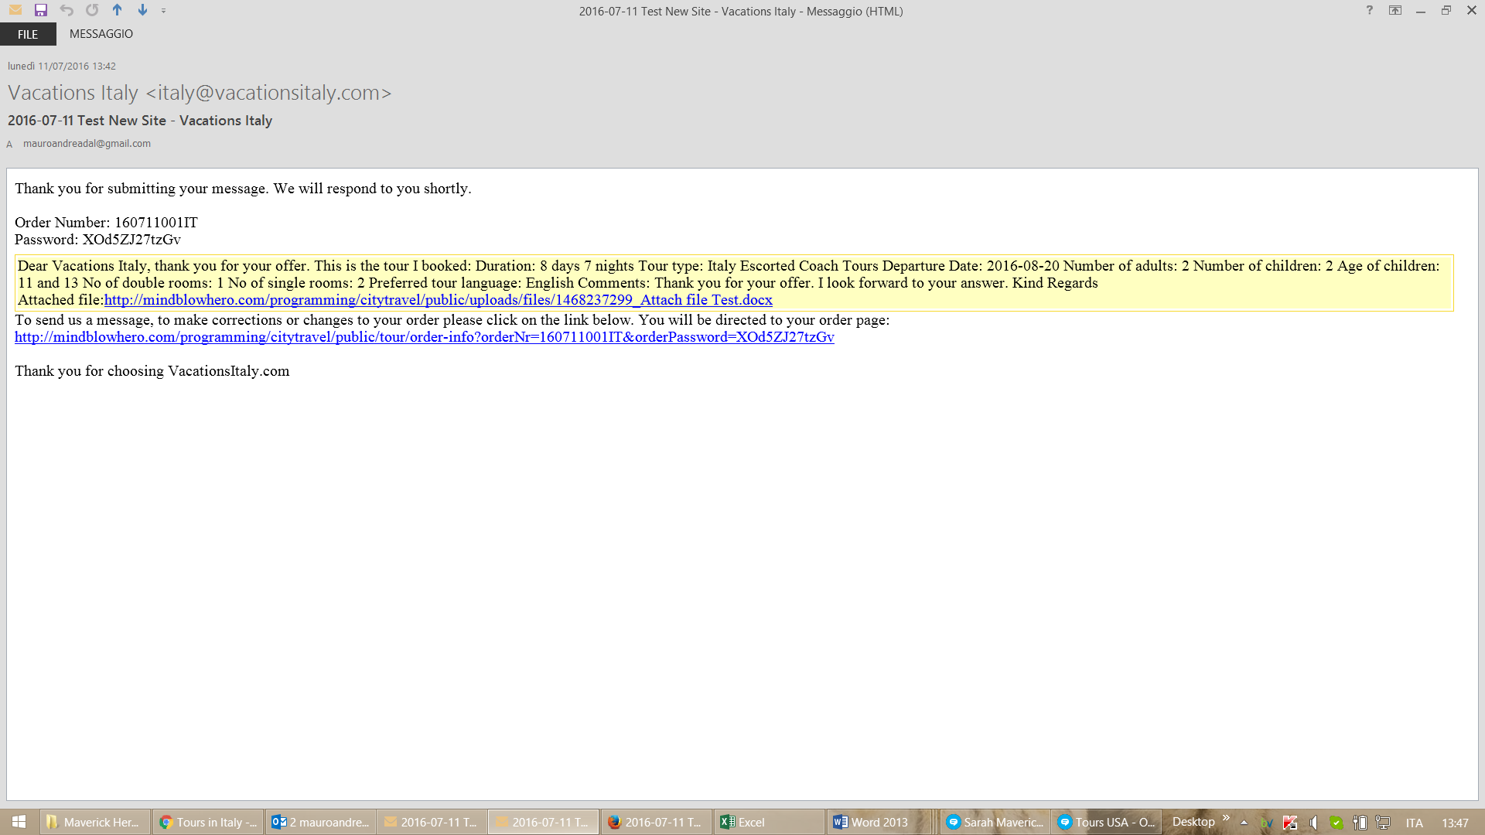

OLD VERSION CORRECT
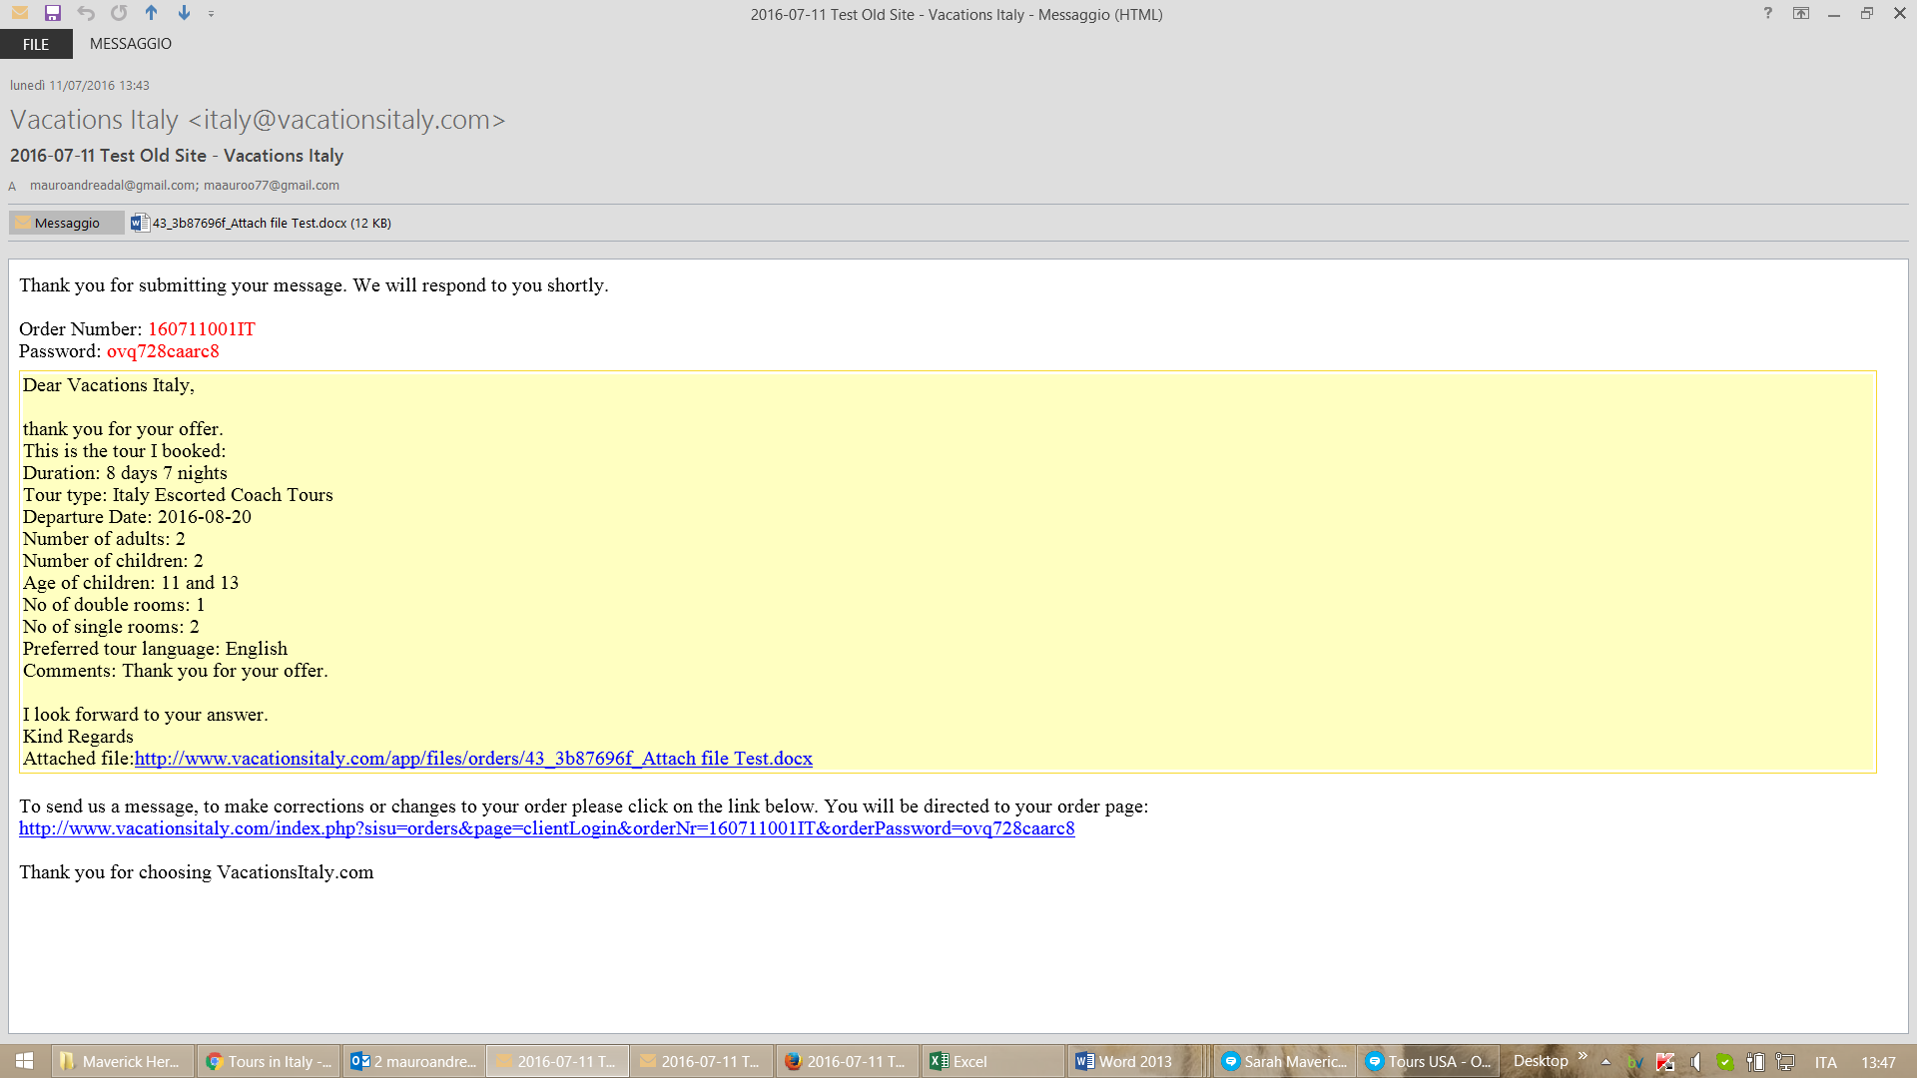

ORDER CONFIRMATION PAGE
- Tour Region: regions must be displayed in one line and also the regions must be listed in the same order decided in CMS. Now they are random and without a precise listing criteria. The order decided in CMS must be used everywhere.
- the sentences of this page must be included in the CMS. Now they are in http://www.vacationsitaly.com/log.php - Settings - Translations - Custom. In this part there are all sentences and also part of Request Form that can be editable. This feature IS part of our agreement because our agreement said that you had to copy all functions of old CMS. So please do it asap.

NEW VERSION WRONG
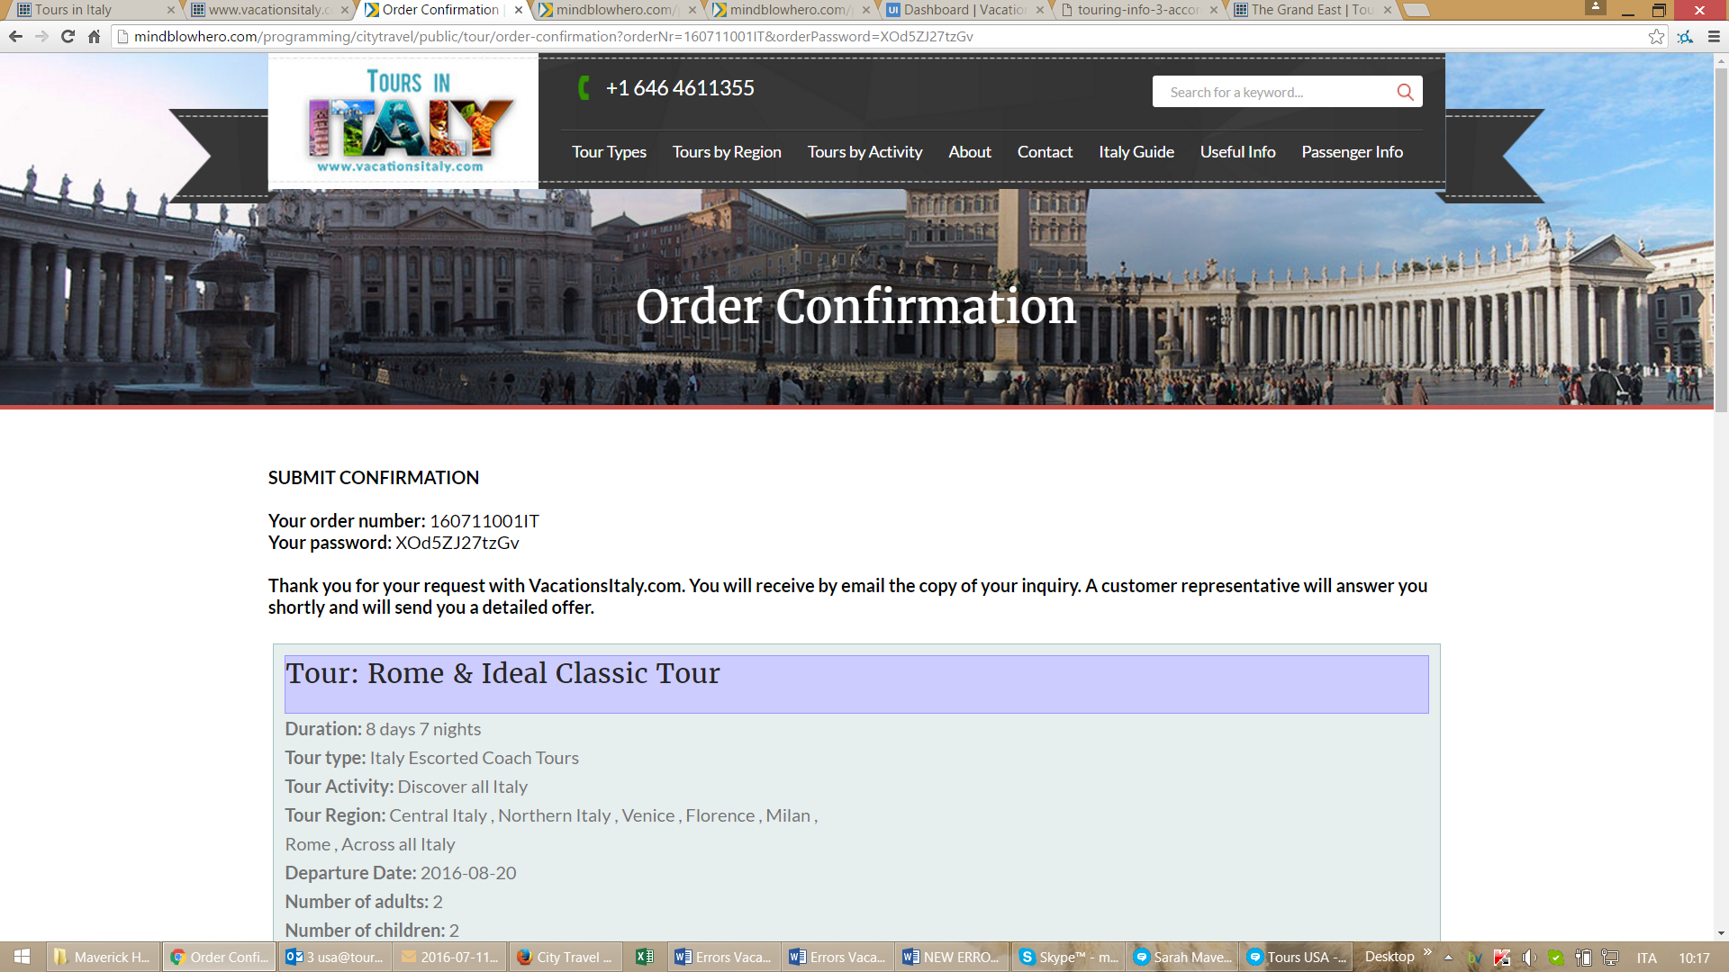

OLD VERSION CORRECT
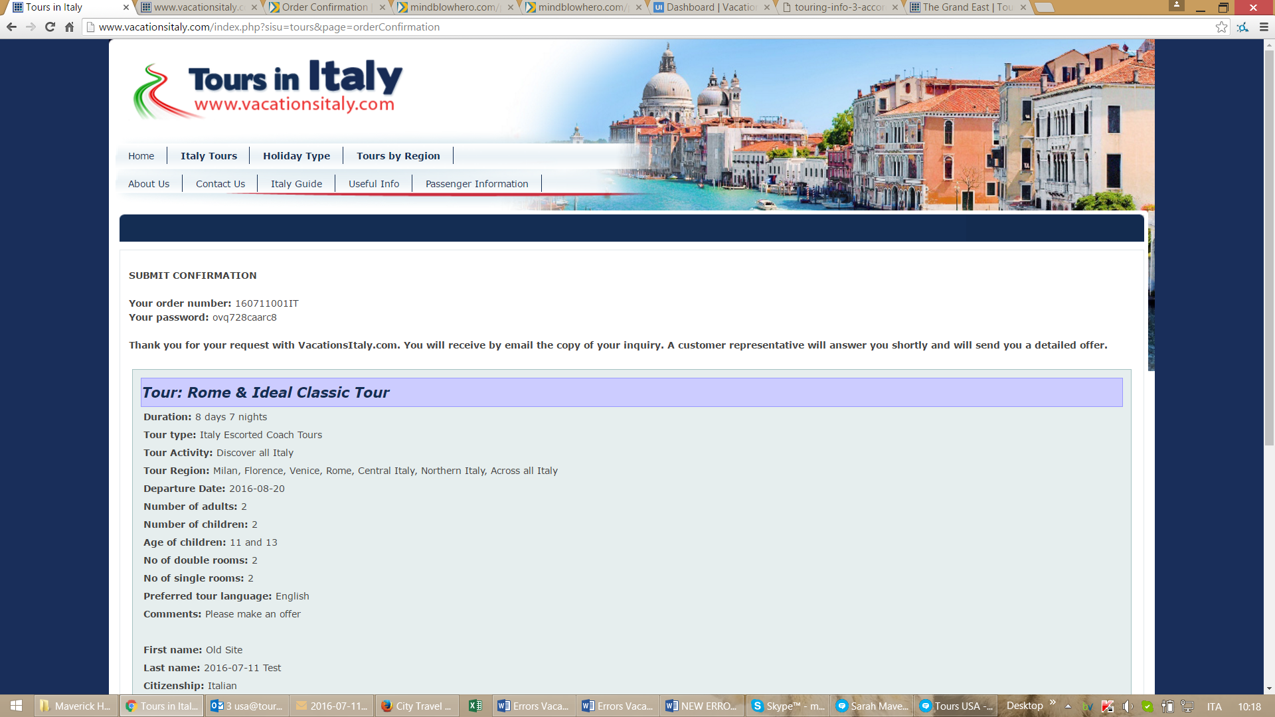

ORDER INFORMATION PAGE
- please make less white space between the top image and the button LOGOUT
- the sentences must be editable in CMS. I don’t see it in CMS. This was part of our agreement.

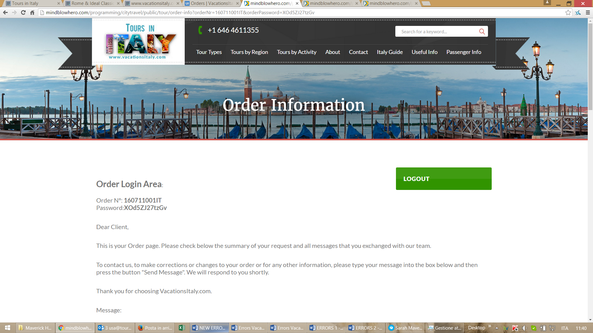

- The message box must be wider like the rest of the page. Now it’s too small. Also please put less white space between the attach files button and the button SEND MESSAGE and also less white space after the button SEND MESSAGE. And less white space at the end of the page before the stylized monuments.

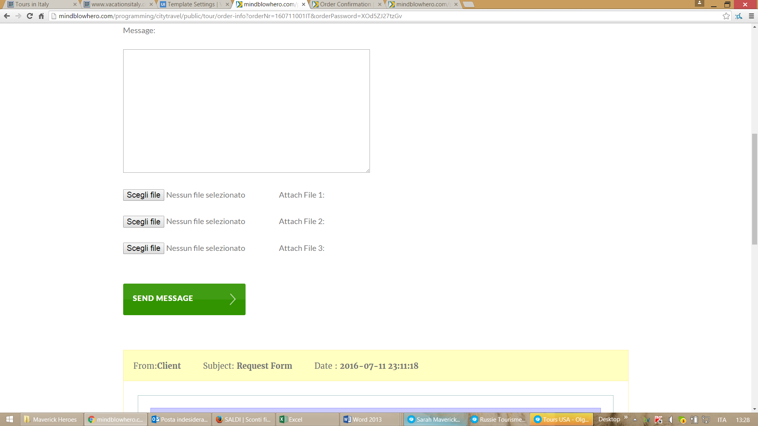

- After clients send a message through the Order Information Page the system does not keep the layout of the message and put all the text next to each other.

NEW VERSION WRONG
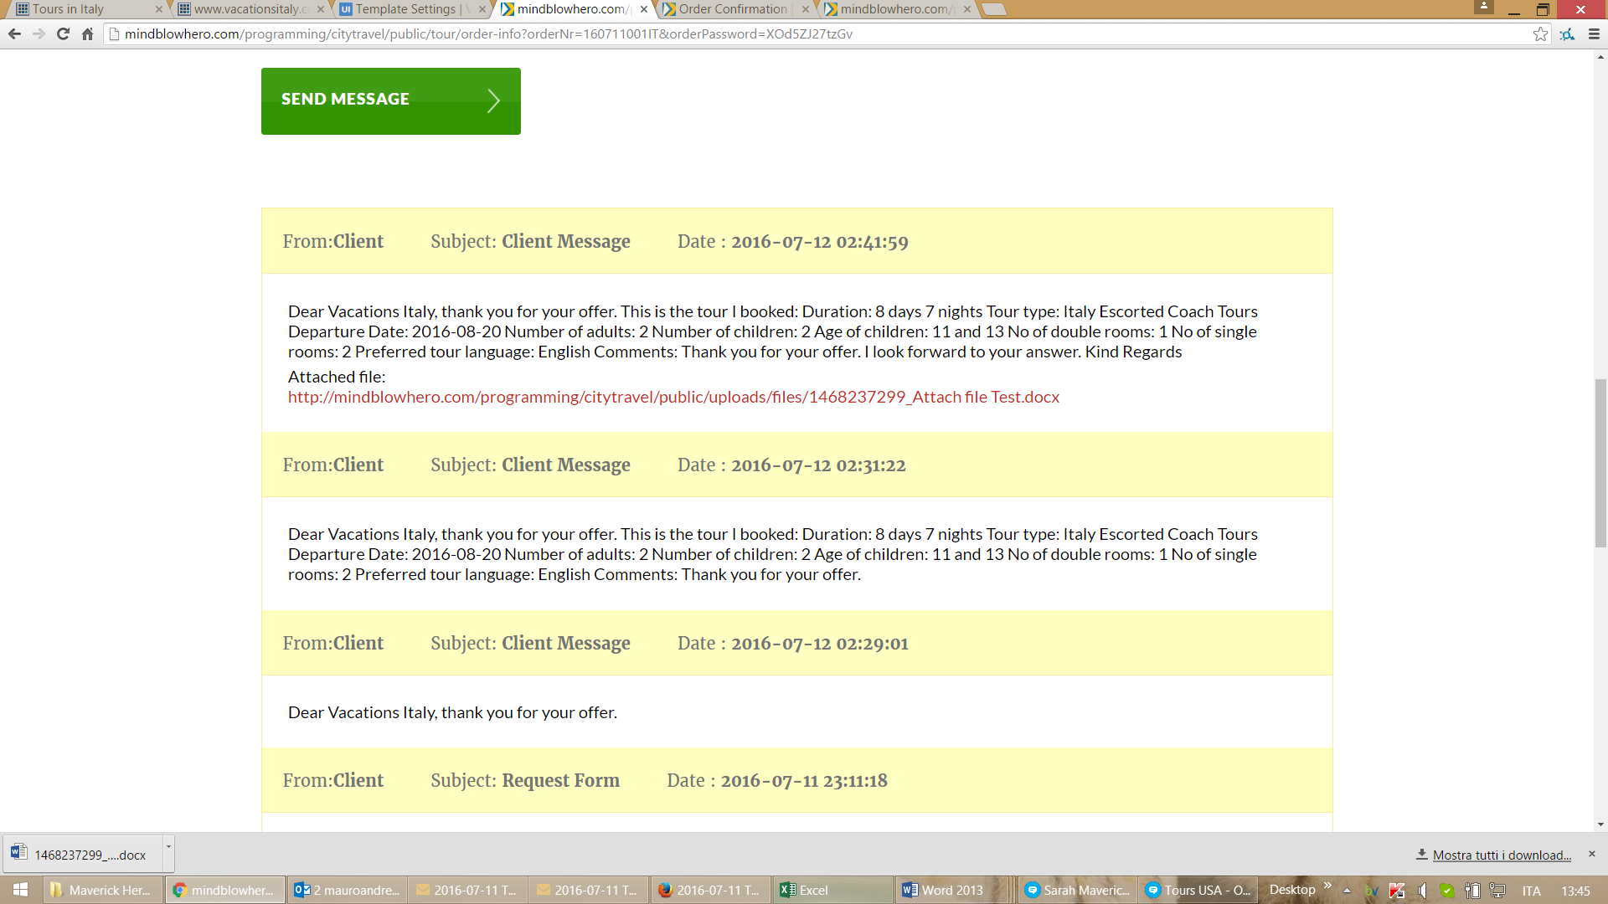

OLD VERSION CORRECT
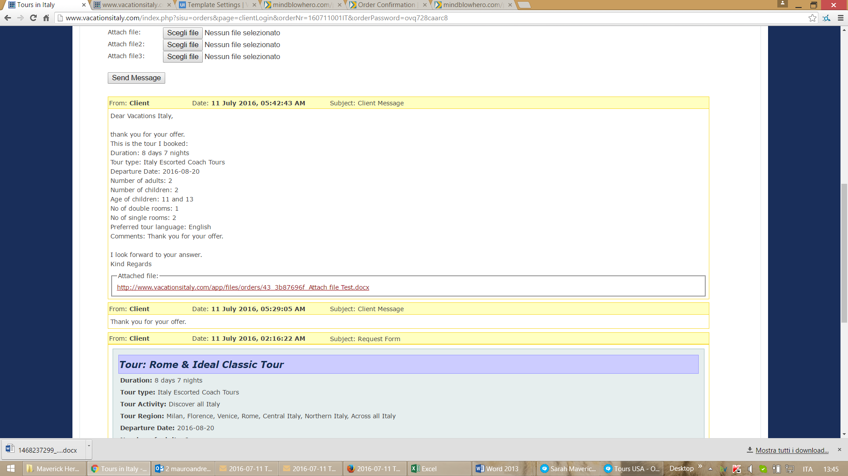

TOUR PAGE DESIGN AND CONTENT
- please put a bit less white space in the end of the tour pages after the button Submit
http://mindblowhero.com/programming/citytravel/public/tour/details/3

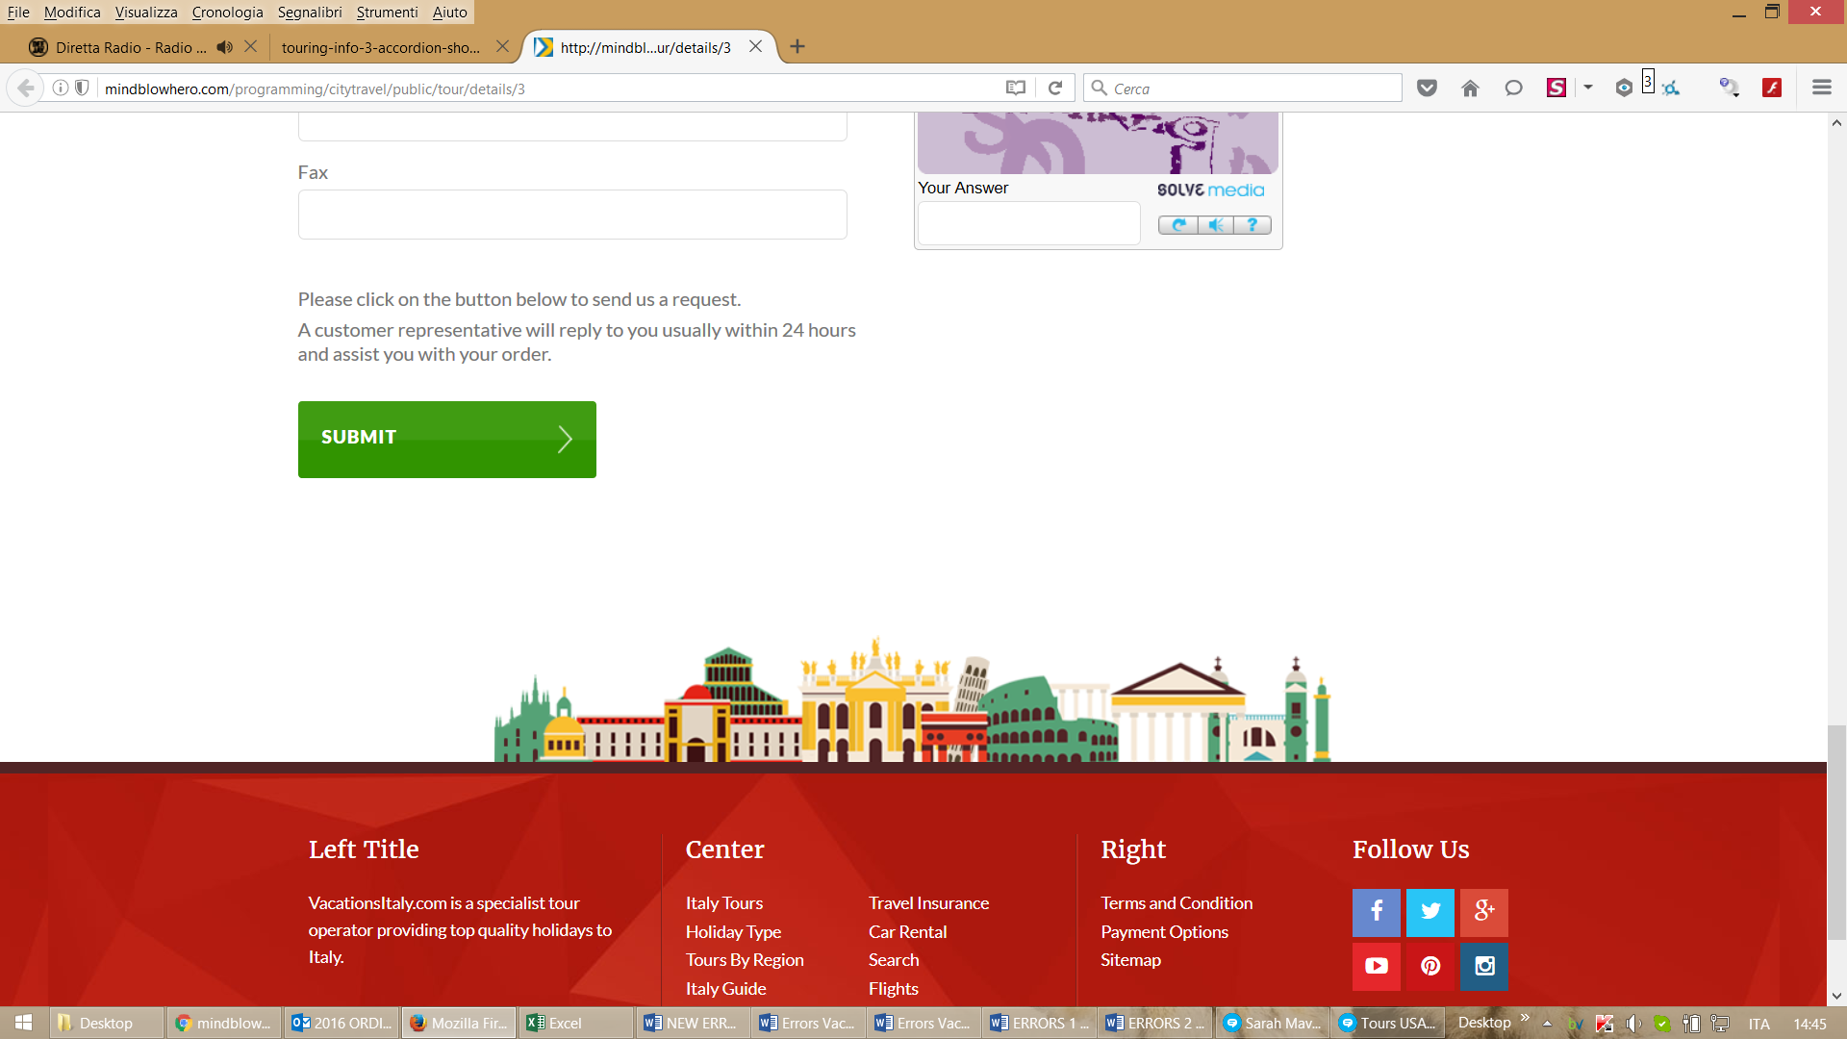

- The title in the tour page should be Tour Information not the name of the tour
http://mindblowhero.com/programming/citytravel/public/tour/details/3
This is what we agreed
http://maverickpreviews.com/design/citytravel/touring-info-3-accordion-shown.html

- please check again that the design you made corresponds to what we agreed. Fonts must be the same of the rest of the site, Top images must be what we agreed etc...
This is what we agreed
https://docs.google.com/spreadsheets/d/1GcjrXkl8ecmm2BiI9cPAPmnYy6GbBYy-cBejxmNTbOw/edit?pref=2&pli=1#gid=0

