IMPORTANT: I ALREADY WROTE ABOUT THE ERRORS BELOW ON 5 OF MAY SO IT’s NOT GOOD THERE ARE STILL THE SAME ERRORS AND YOU DID NON CORRECT THEM.

**EMAILS**

- when we or client write the system does not send anymore emails to our address [italy@vacationsitaly.com](mailto:italy@vacationsitaly.com). Please URGENTLY CHECK

**CLIENT’S ORDER PAGE**

- when we send a payment to a client the first part of client’s order page must change and there are some sentences that must appear. These sentences must be editable in CMS. Please compare below. Moreover the layout is wrong with a big yellow row.

- the payment form at the end must contain the symbol and a link opened only in a new page of the browser (not in the same page) to our payment provider Klikandpay

NEW VERSION WRONG

<http://mindblowhero.com/programming/citytravel/public/tour/order-info?orderNr=160711001IT&orderPassword=XOd5ZJ27tzGv>

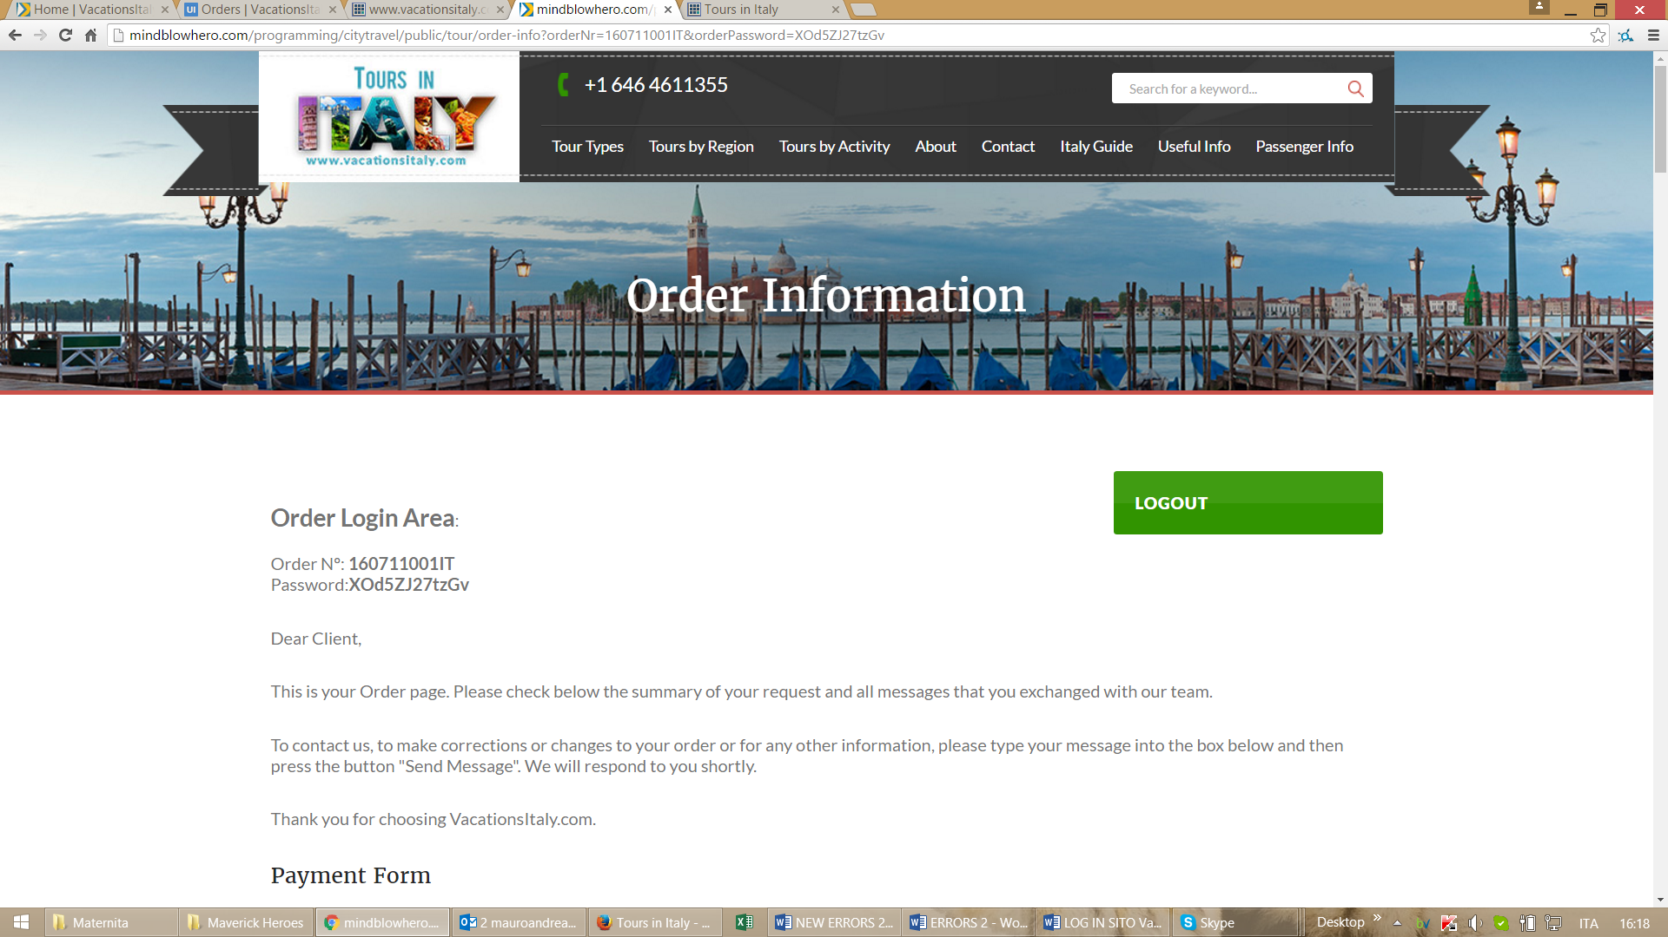

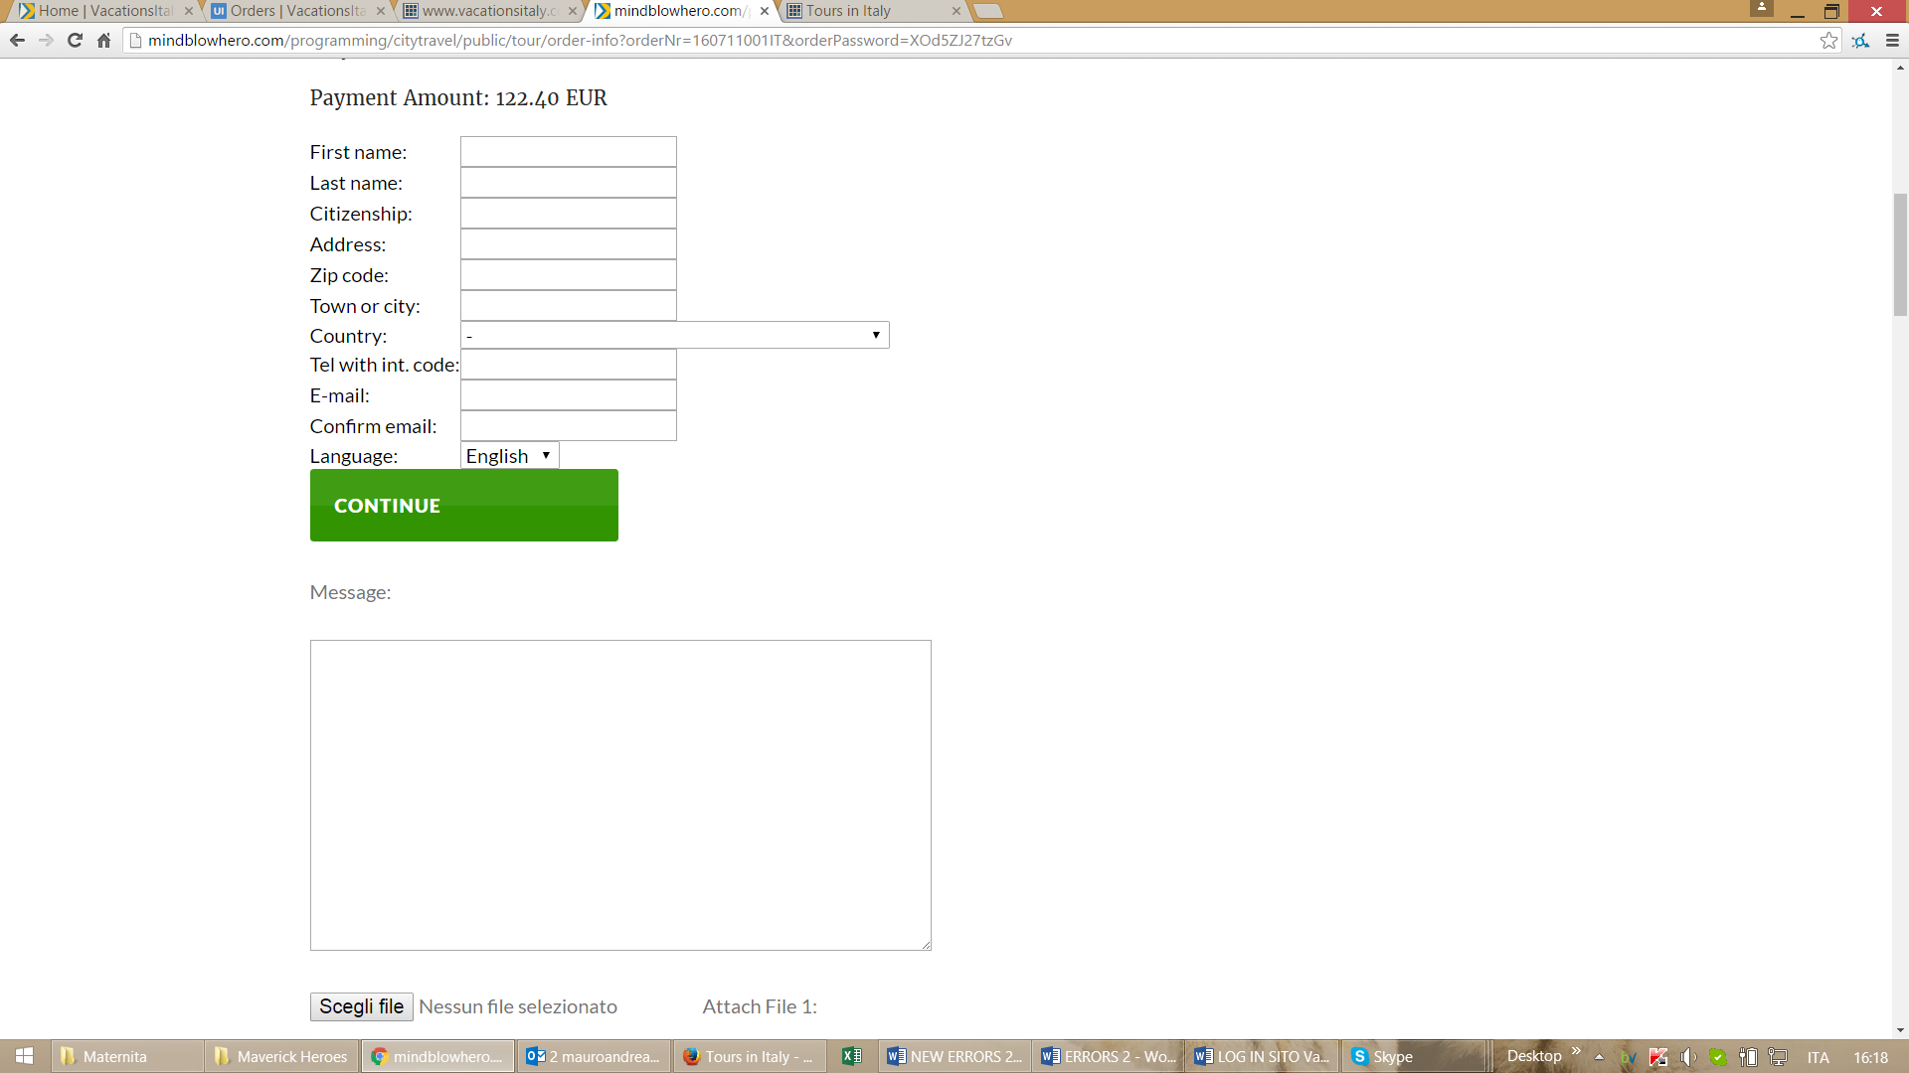

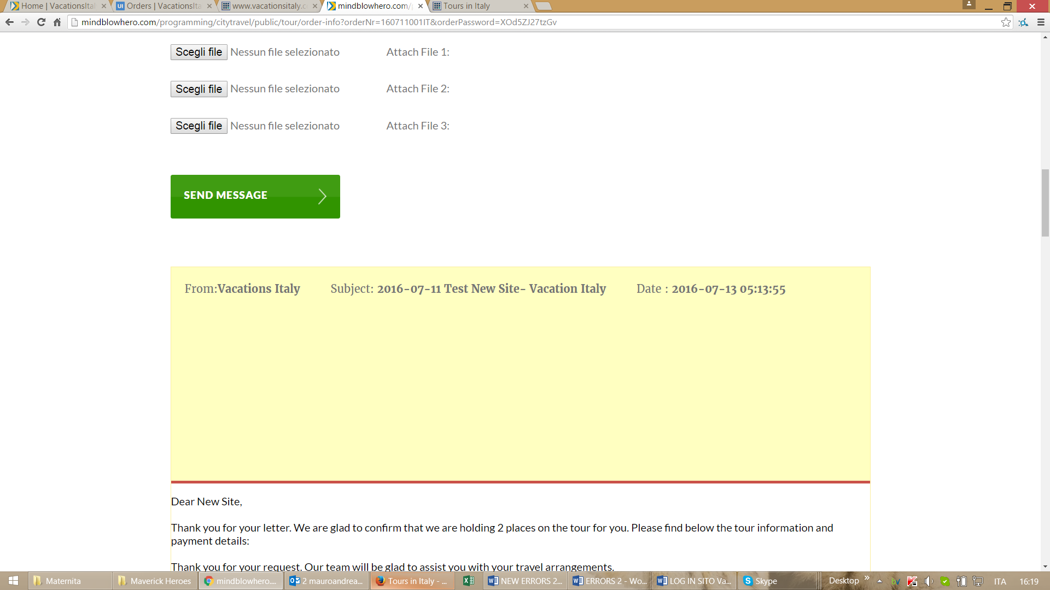

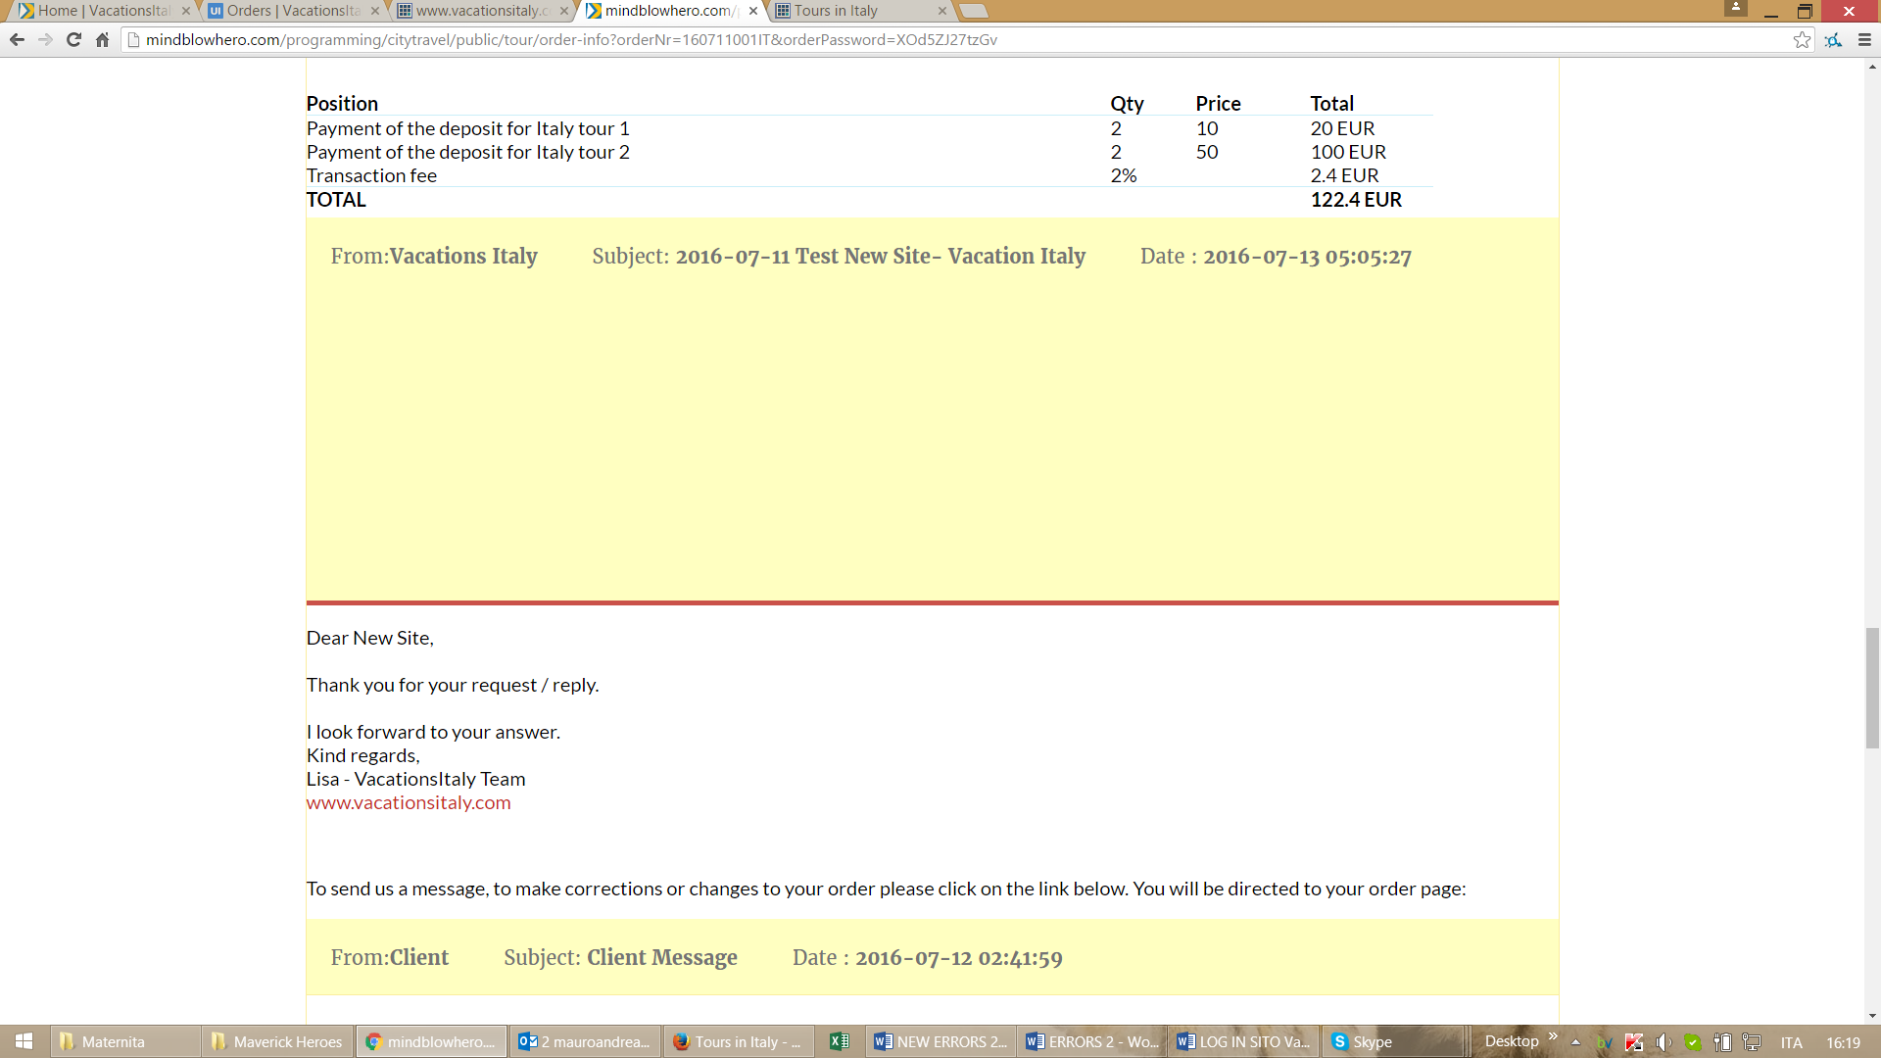

OLD VERSION CORRECT

<http://www.vacationsitaly.com/index.php?sisu=orders&page=clientLogin&orderNr=160711001IT&orderPassword=ovq728caarc8>

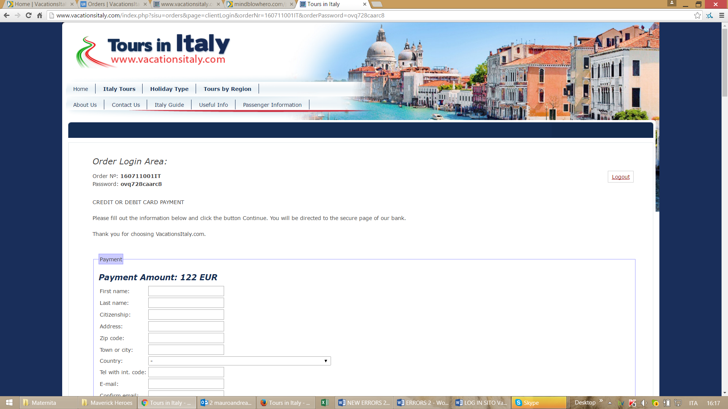

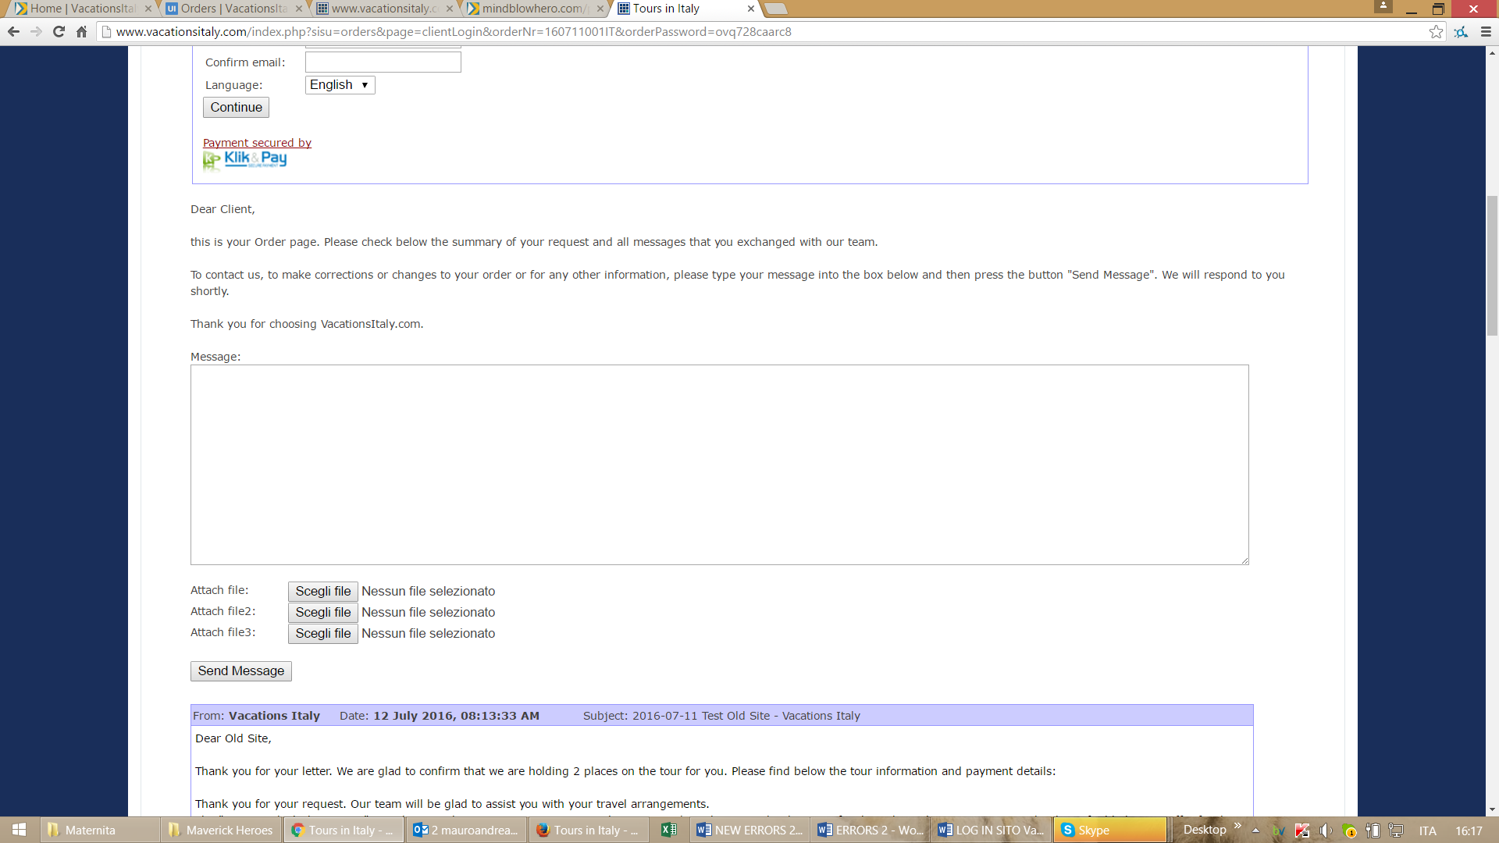

**ORDERS CONTROL PANEL**

- when a client sends a message from hiS order page the line of that order in the order list must be yellow. Please compare screenshots below

NEW VERSION WRONG

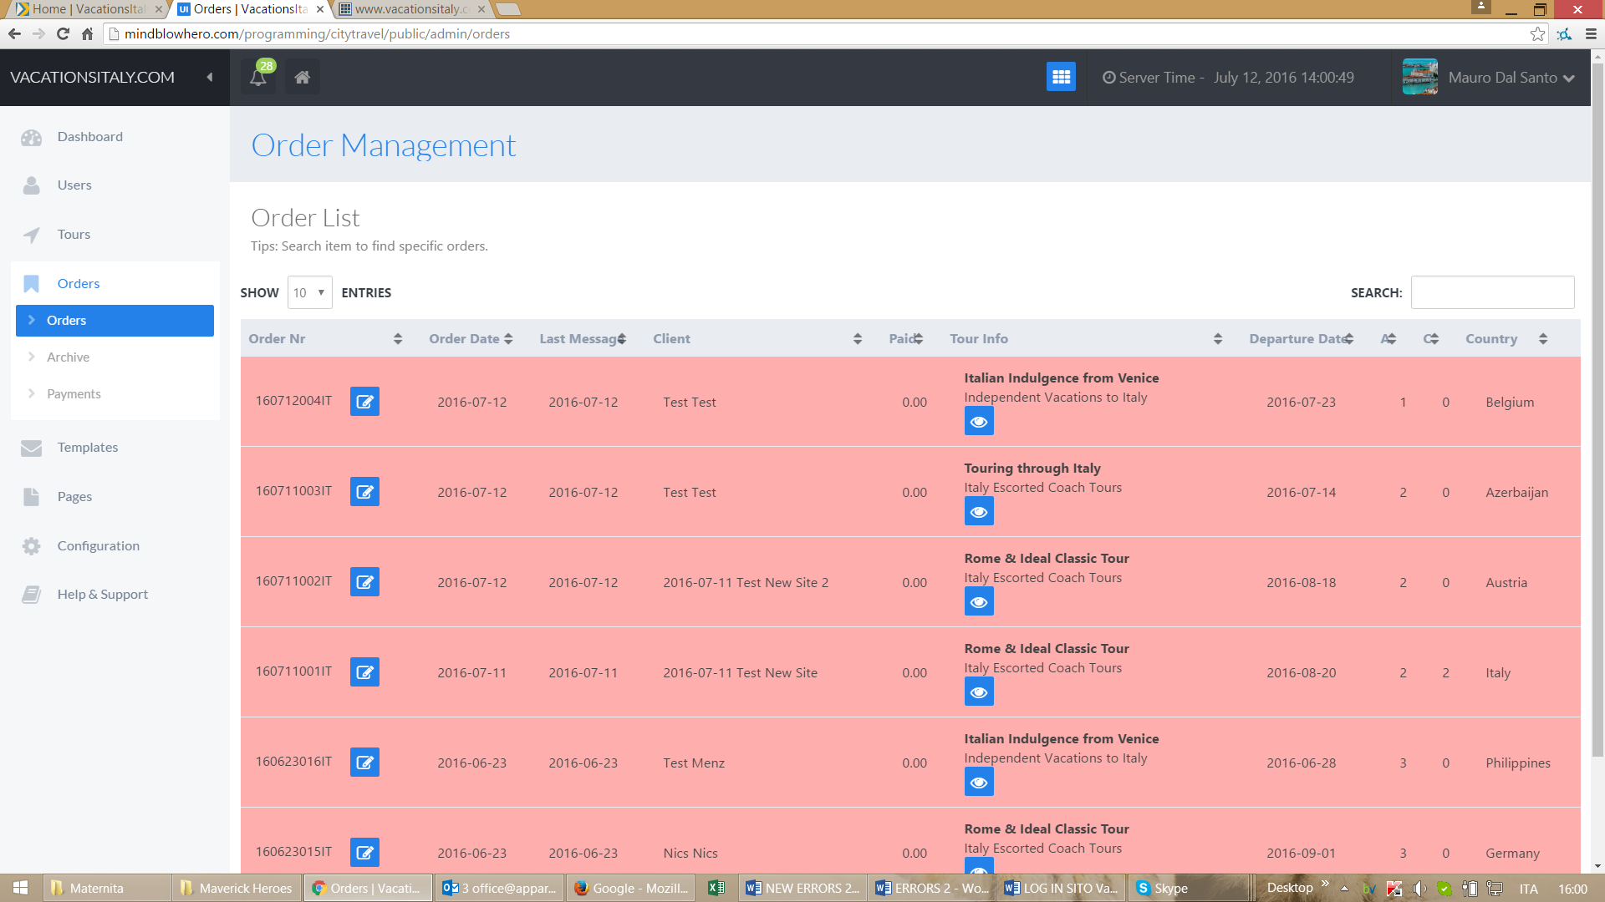

OLD VERSION CORRECT

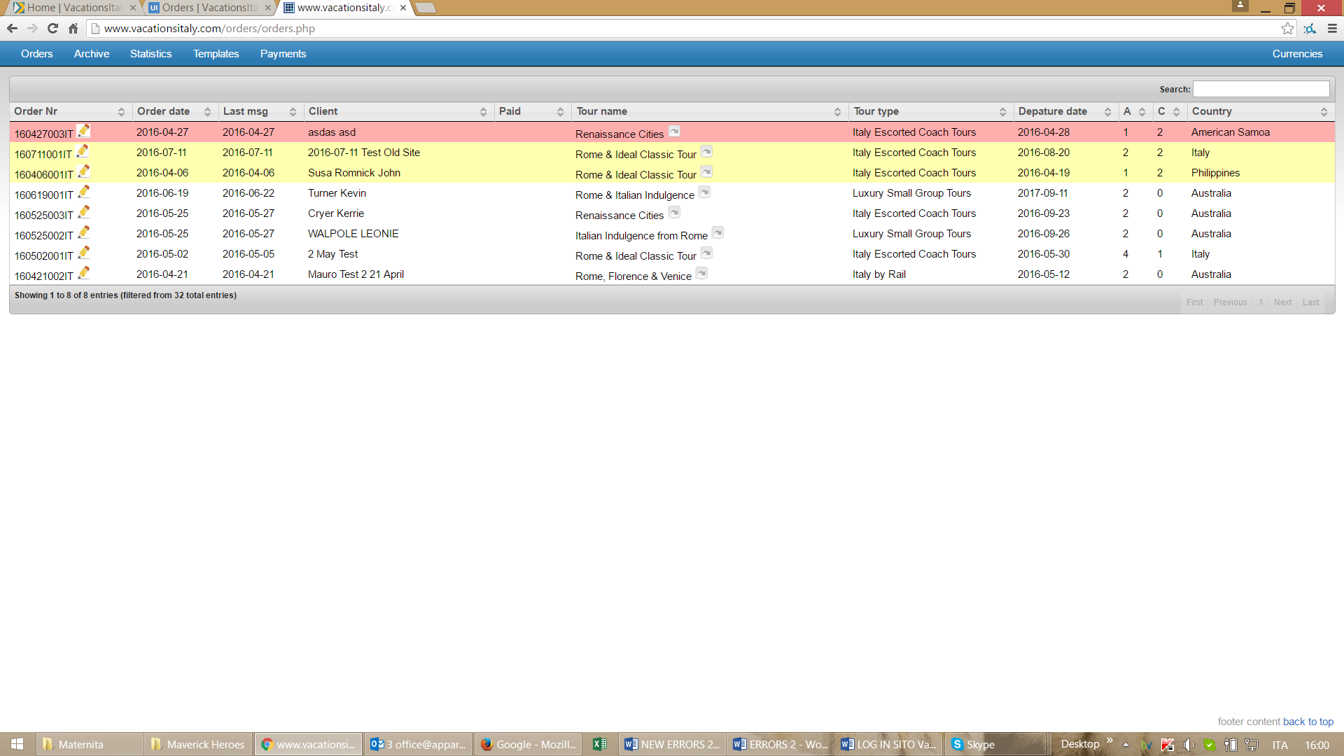

- when se send a message to a client the order must automatically become white. Now it always remain red. Please compare below

NEW VERSION WRONG

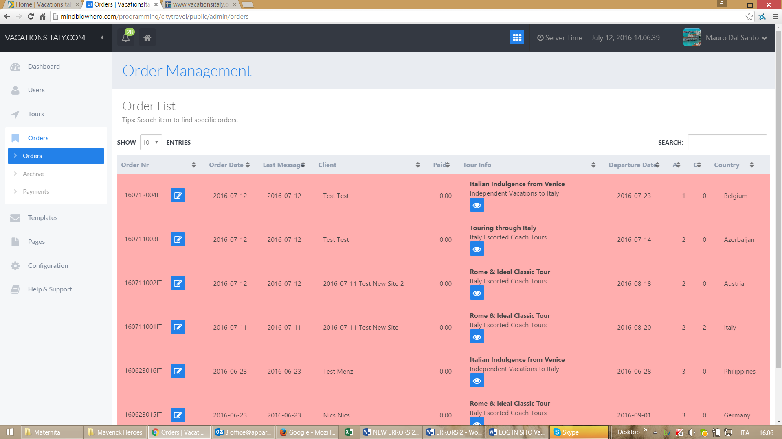

OLD VERSION CORRECT

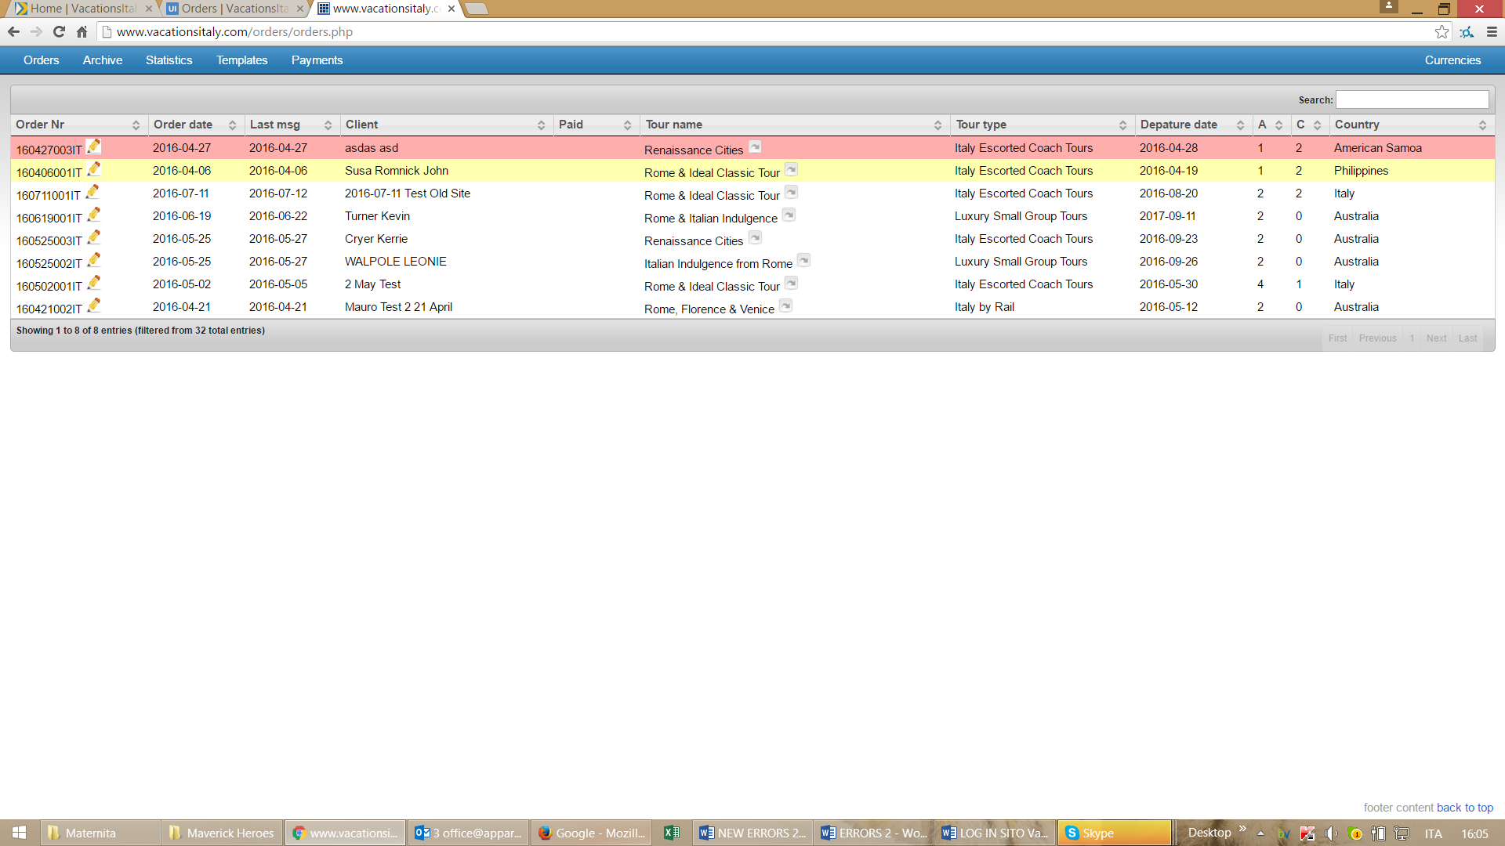

- the box where we write answers to clients from order control panel must be bigger. Now it’s too small. Please compare

NEW VERSION WRONG

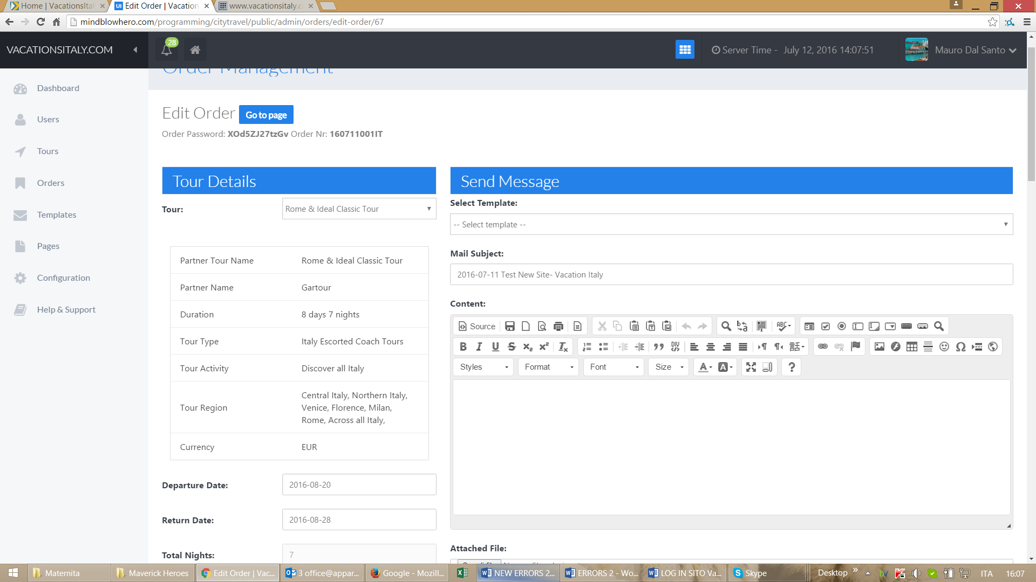

OLD VERSION CORRECT

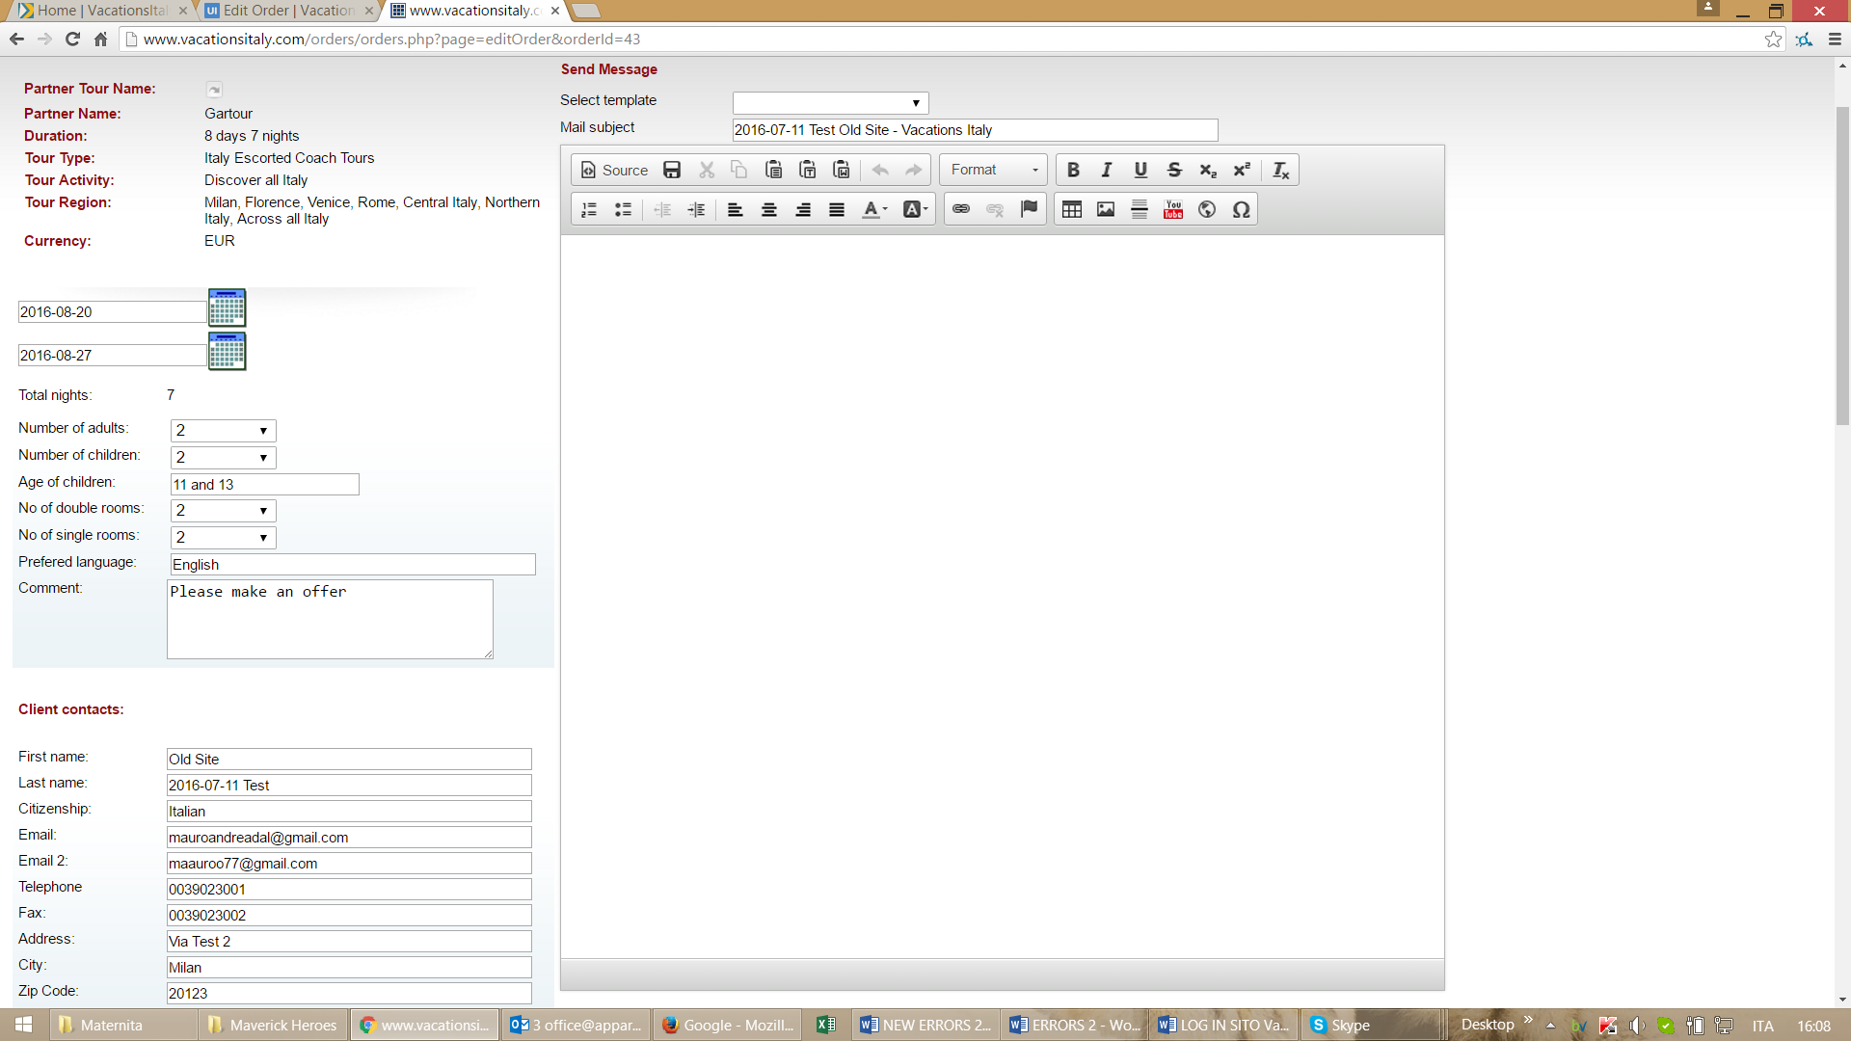

- when we send a payment to a client and we put in the payment lines a number like 100 or 5000 the system write such numbers as 1.00 and 50.00 and it’s wrong. And also make wrong calculations. See below

NEW VERSION WRONG

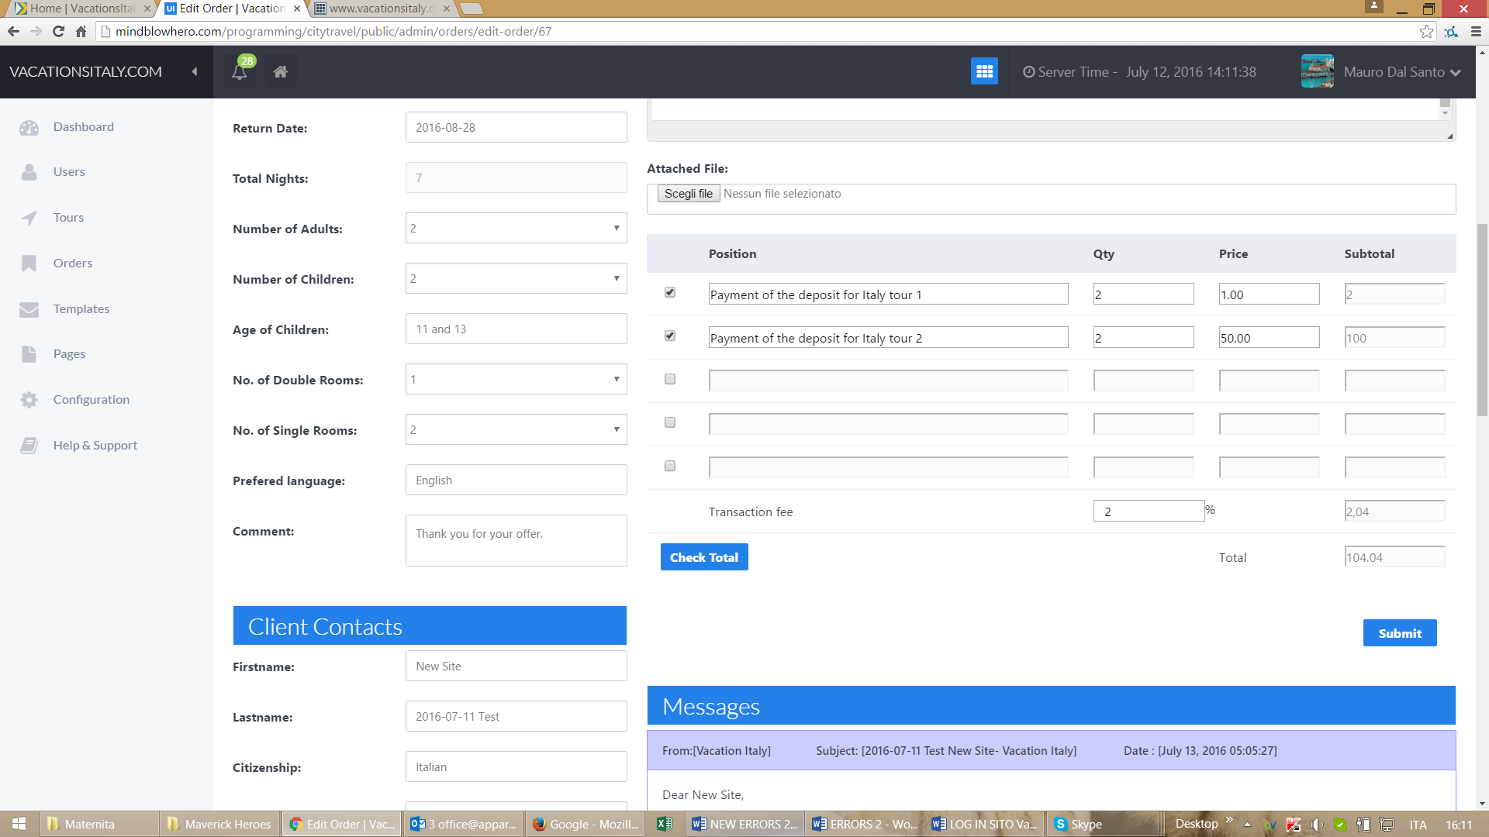

OLD VERSION CORRECT

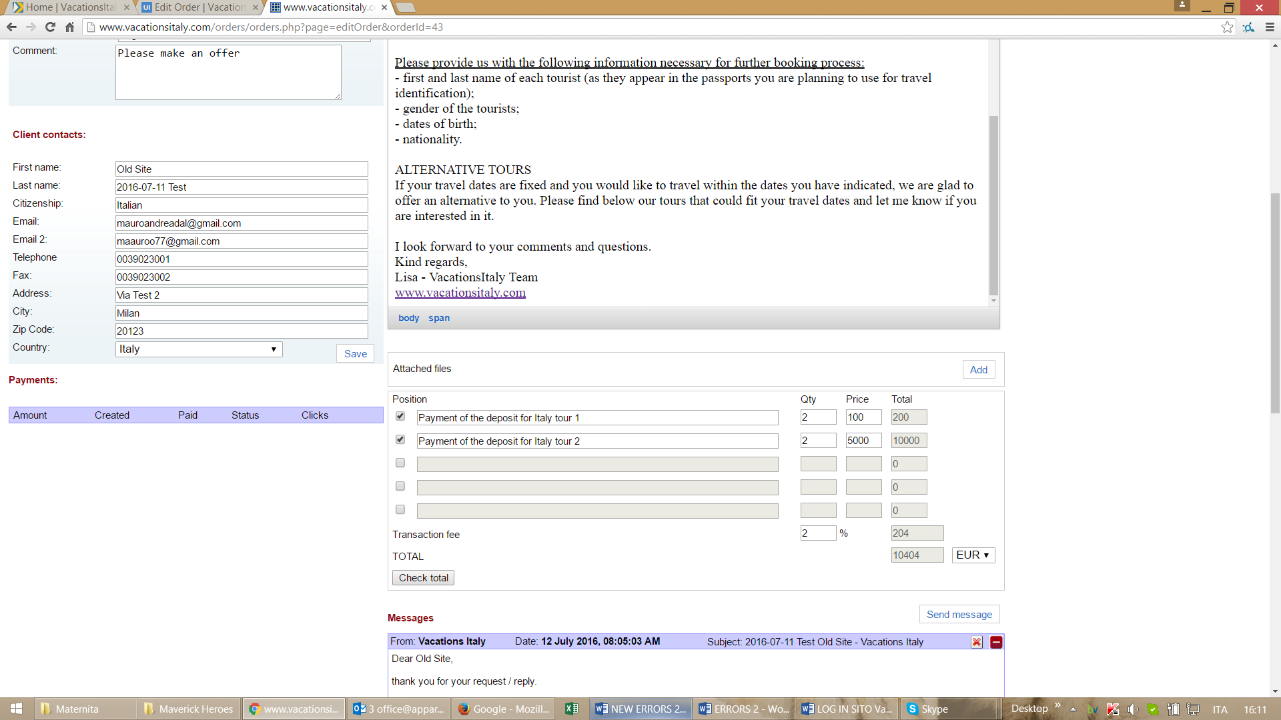

- the payment system must use round numbers without decimals

NEW VERSION WRONG

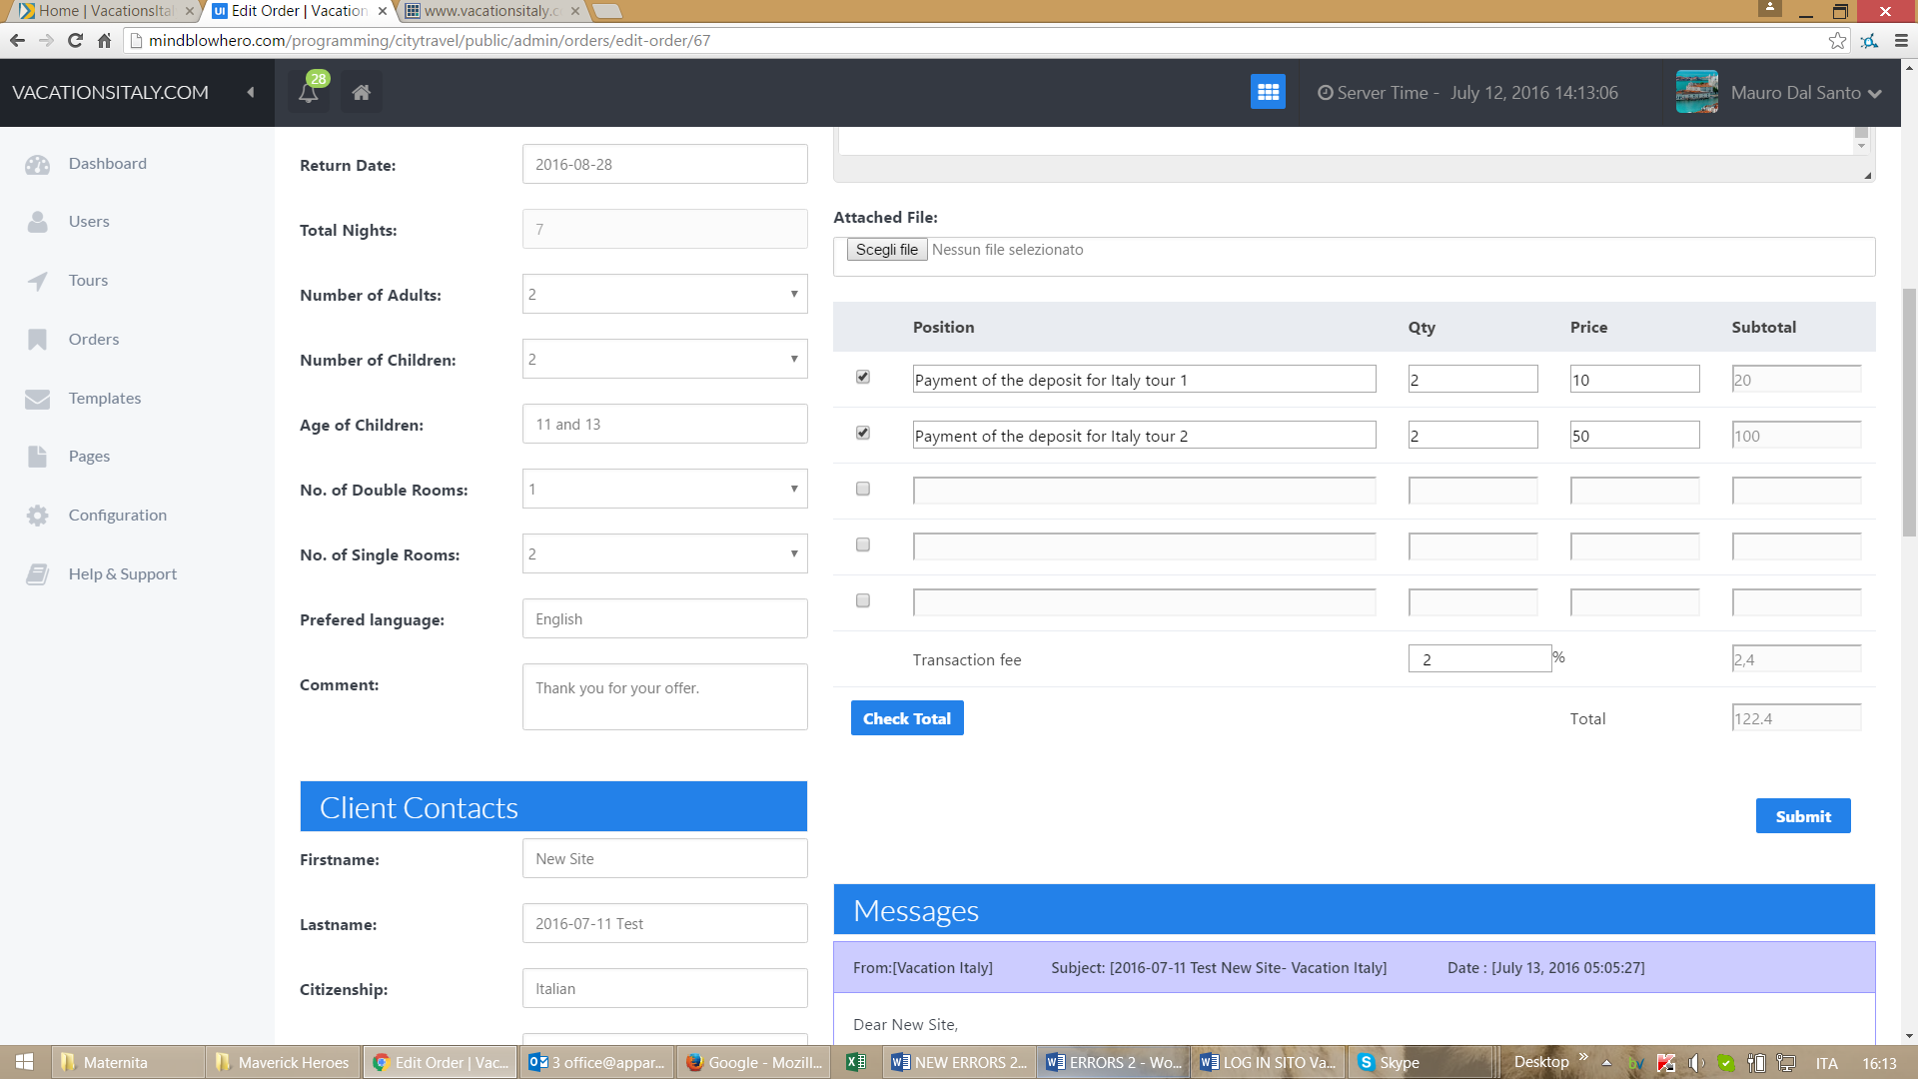

OLD VERSION CORRECT

